Lenin on Prioritizing Unity With the Workers and not Intellectual Groups
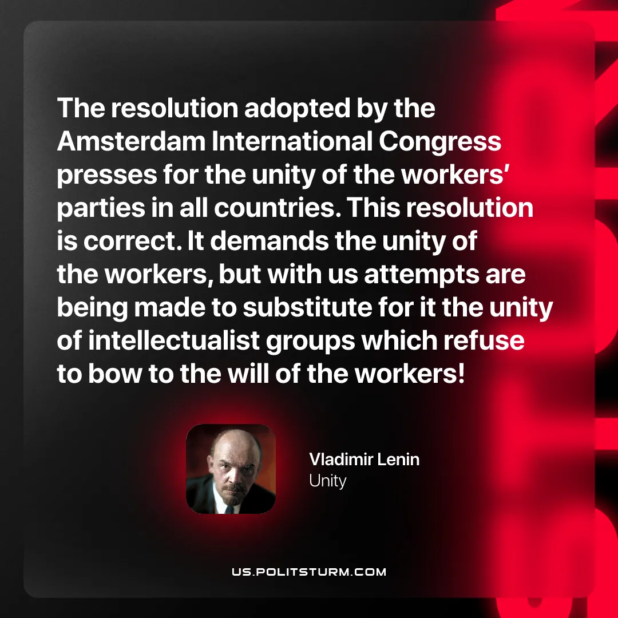

Original article
2026-04-18

“The resolution adopted by the Amsterdam International Congress presses for the unity of the workers’ parties in all countries. This resolution is correct. It demands the unity of the workers, but with us attempts are being made to substitute for it the unity of intellectualist groups which refuse to bow to the will of the workers!”
Vladimir Lenin, Unity

Original article

