Lenin on Deciding the Path of Struggle
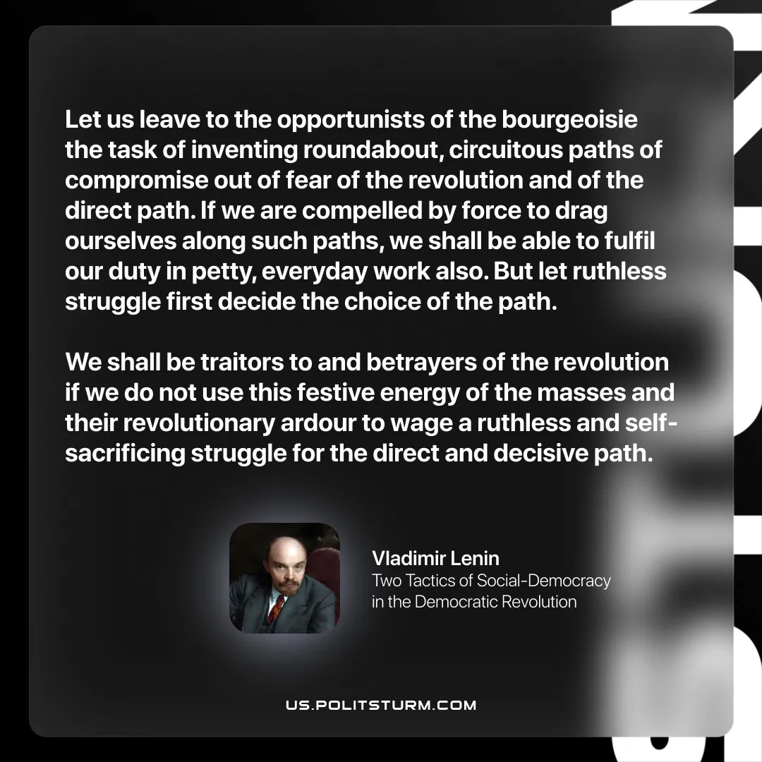

Original article
2026-04-04
1 min read

“Let us leave to the opportunists of the bourgeoisie the task of inventing roundabout, circuitous paths of compromise out of fear of the revolution and of the direct path. If we are compelled by force to drag ourselves along such paths, we shall be able to fulfil our duty in petty, everyday work also. But let ruthless struggle first decide the choice of the path. We shall be traitors to and betrayers of the revolution if we do not use this festive energy of the masses and their revolutionary ardour to wage a ruthless and self-sacrificing struggle for the direct and decisive path.”
Vladimir Lenin, Two Tactics of Social-Democracy in the Democratic Revolution

Original article

