Lenin on Supporting Imperialist Wars
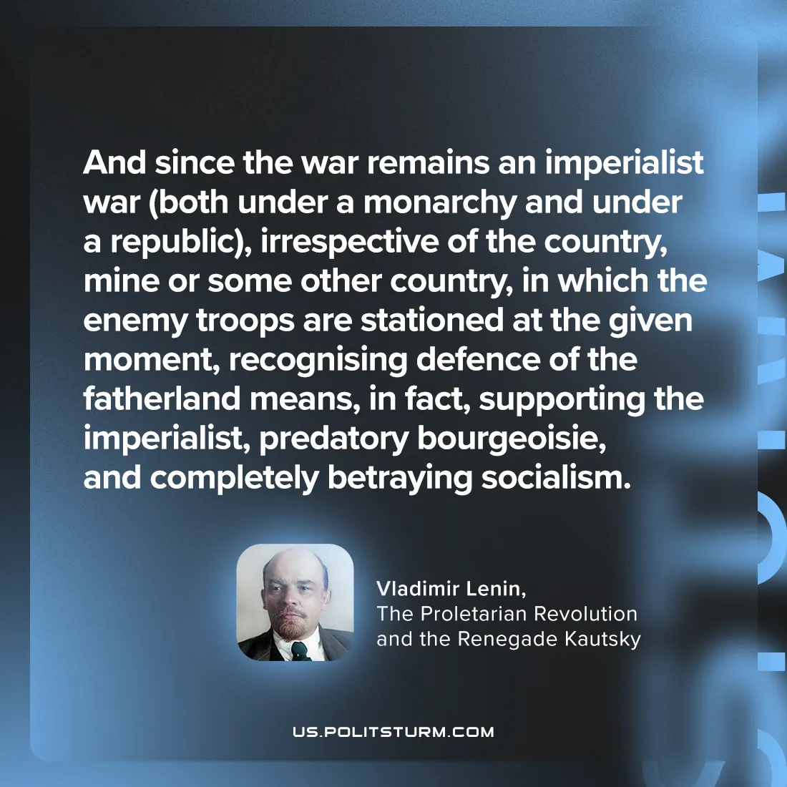

Original article
2024-07-28

"And since the war remains an imperialist war (both under a monarchy and under a republic), irrespective of the country—mine or some other country—in which the enemy troops are stationed at the given moment, recognising defence of the fatherland means, in fact, supporting the imperialist, predatory bourgeoisie, and completely betraying socialism."
Vladimir Lenin, The Proletarian Revolution and the Renegade Kautsky

Original article

