Lenin on how Conflicts Push the Workers Towards Revolutionary Parties
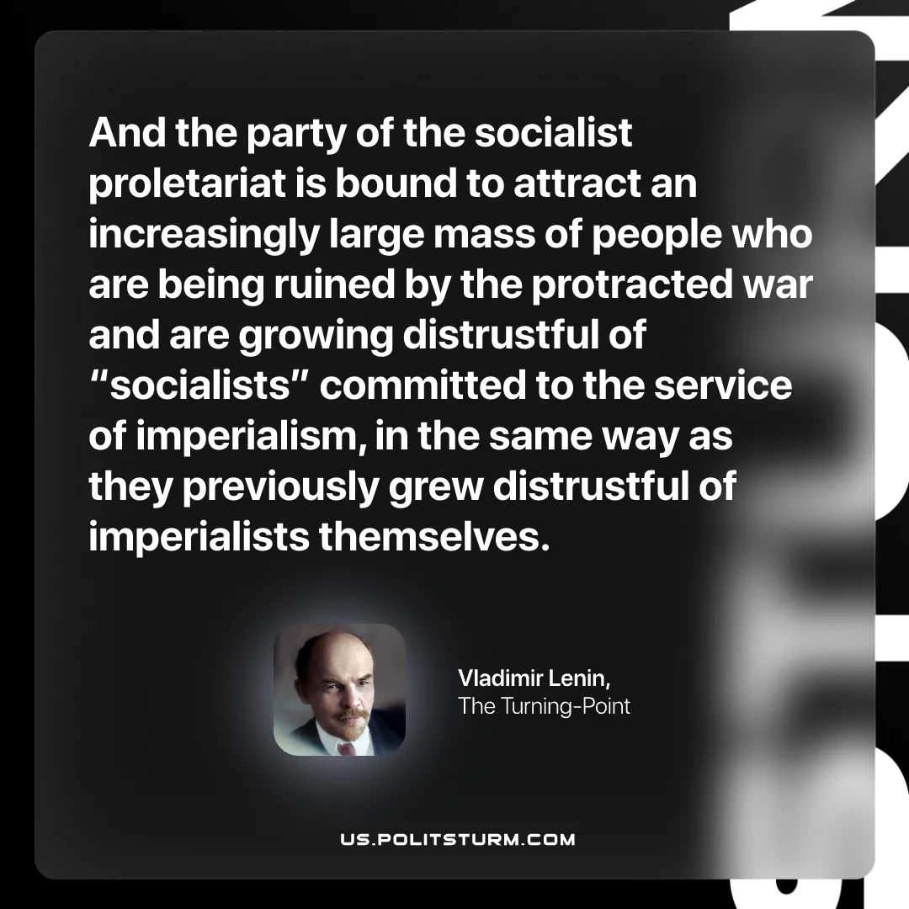

Original article
2026-03-15

“And the party of the socialist proletariat is bound to attract an increasingly large mass of people who are being ruined by the protracted war and are growing distrustful of “socialists” committed to the service of imperialism, in the same way as they previously grew distrustful of imperialists themselves.”
Vladimir Lenin, The Turning-Point

Original article

