Lenin on the Inequality Maintained by the State
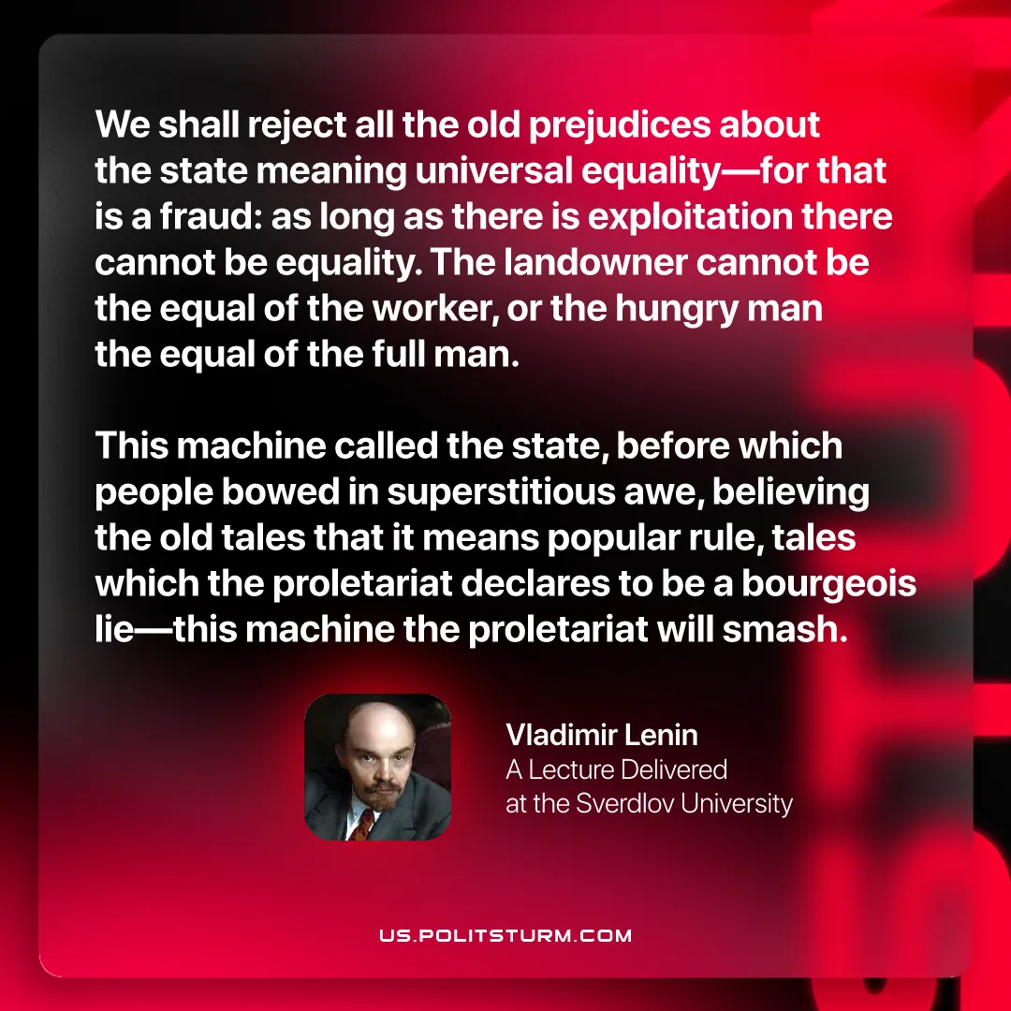

Original article
2026-03-03
1 min read

“We shall reject all the old prejudices about the state meaning universal equality—for that is a fraud: as long as there is exploitation there cannot be equality. The landowner cannot be the equal of the worker, or the hungry man the equal of the full man. This machine called the state, before which people bowed in superstitious awe, believing the old tales that it means popular rule, tales which the proletariat declares to be a bourgeois lie—this machine the proletariat will smash.”
Vladimir Lenin, A Lecture Delivered at the Sverdlov University

Original article

