Lenin on Peace and Continuation of Wars
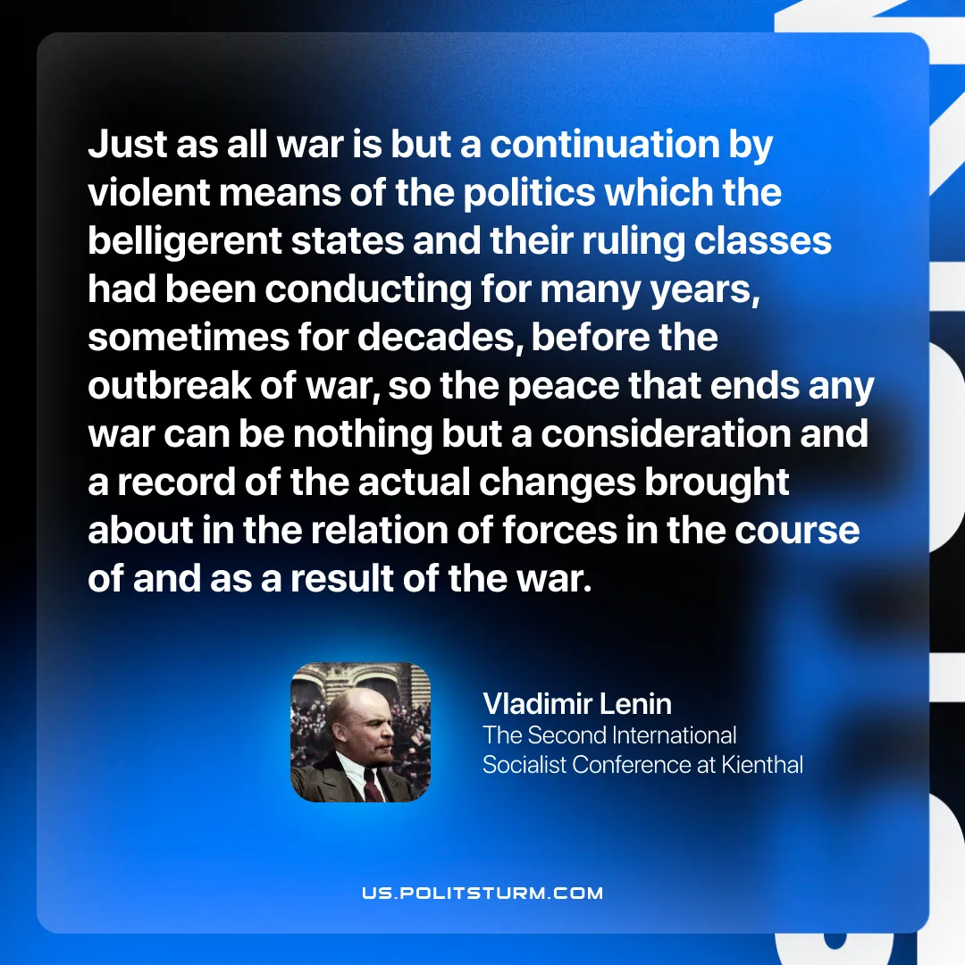

Original article
2025-12-18
1 min read

“Just as all war is but a continuation by violent means of the politics which the belligerent states and their ruling classes had been conducting for many years, sometimes for decades, before the outbreak of war, so the peace that ends any war can be nothing but a consideration and a record of the actual changes brought about in the relation of forces in the course of and as a result of the war.
Vladimir Lenin, Proposals Submitted by the Central Committee of the R.S.D.L.P. to the Second Socialist Conference

Original article

