Lenin on Revolutionary Integrity Under Reactionary Conditions
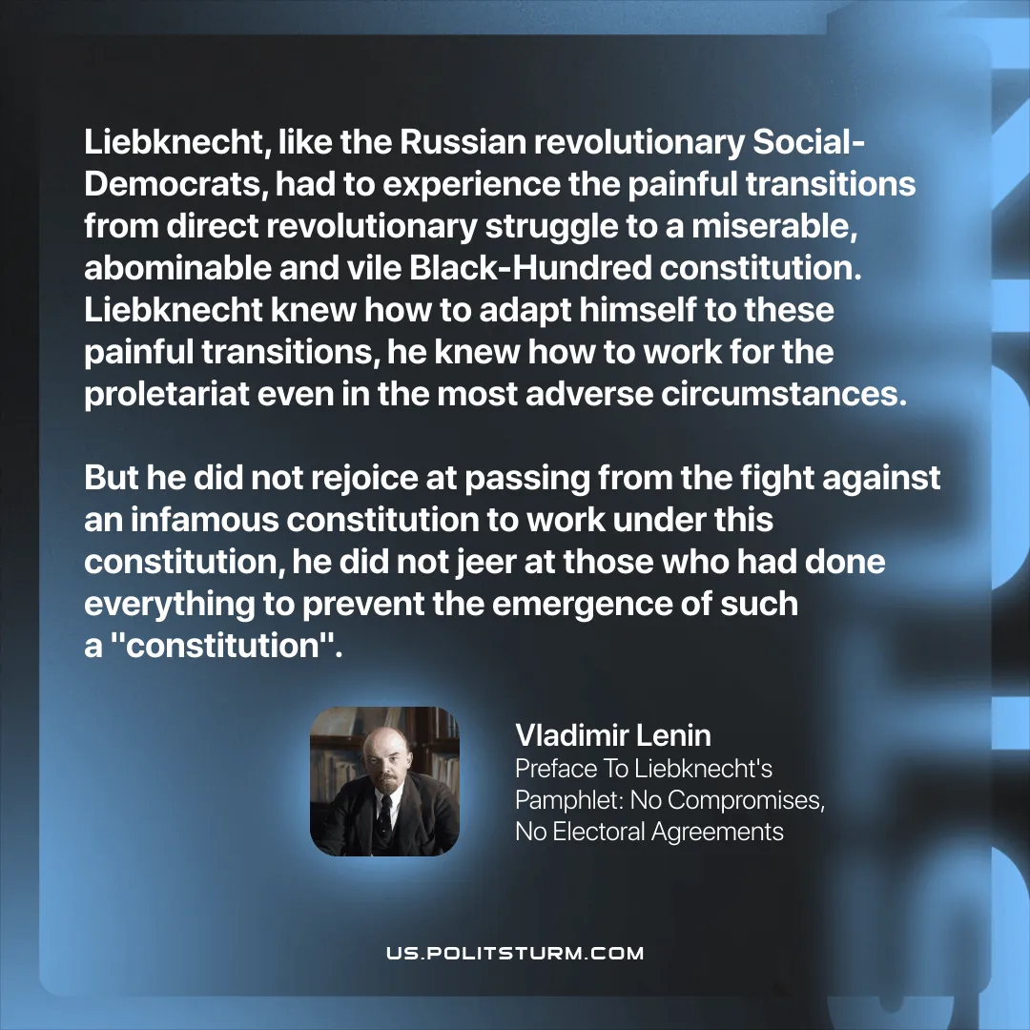

Original article
2025-11-29
1 min read

“Liebknecht, like the Russian revolutionary Social-Democrats, had to experience the painful transitions from direct revolutionary struggle to a miserable, abominable and vile Black-Hundred constitution. Liebknecht knew how to adapt himself to these painful transitions, he knew how to work for the proletariat even in the most adverse circumstances. But he did not rejoice at passing from the fight against an infamous constitution to work under this constitution, he did not jeer at those who had done everything to prevent the emergence of such a "constitution". Vladimir Lenin, Preface To Liebknecht's Pamphlet: No Compromises, No Electoral Agreements

Original article

