Lenin on the Essence of Opportunism
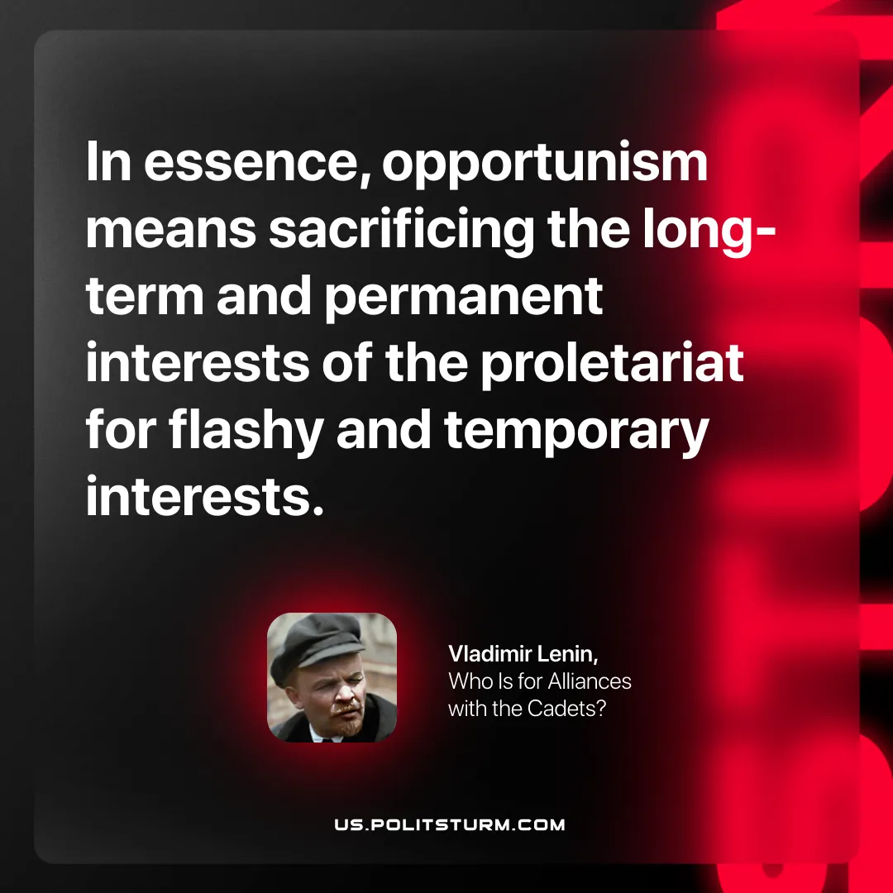

Original article
2025-11-23

“In essence, opportunism means sacrificing the long-term and permanent interests of the proletariat for flashy and temporary interests.”
Vladimir Lenin, Who Is for Alliances with the Cadets?

Original article

