Lenin on Present Relations Oppressing Weak Nations
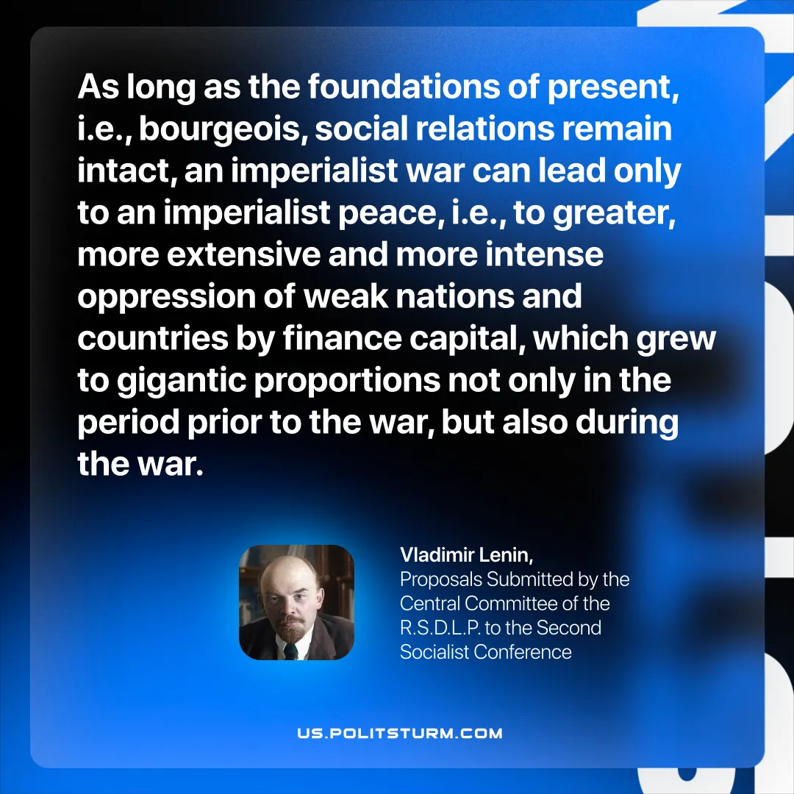

Original article
2025-11-20

“As long as the foundations of present, i.e., bourgeois, social relations remain intact, an imperialist war can lead only to an imperialist peace, i.e., to greater, more extensive and more intense oppression of weak nations and countries by finance capital, which grew to gigantic proportions not only in the period prior to the war, but also during the war.”
Vladimir Lenin, Proposals Submitted by the Central Committee of the R.S.D.L.P. to the Second Socialist Conference

Original article

