Lenin on Opposition and Confusion towards Calling Wars Imperialist
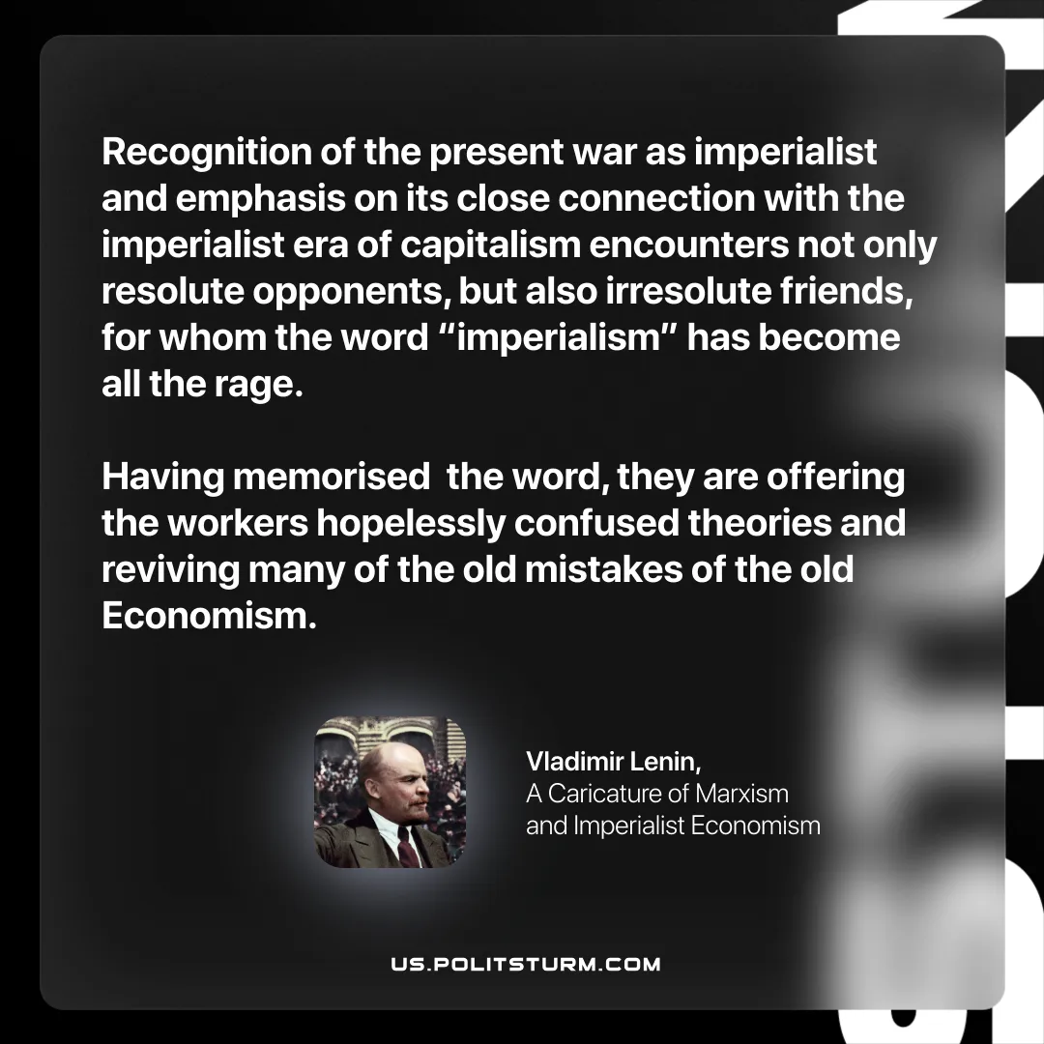

Original article
2025-11-18

“Recognition of the present war as imperialist and emphasis on its close connection with the imperialist era of capitalism encounters not only resolute opponents, but also irresolute friends, for whom the word“imperialism” has become all the rage. Having memorised the word, they are offering the workers hopelessly confused theories and reviving many of the old mistakes of the old Economism.
Vladimir Lenin, A Caricature of Marxism and Imperialist Economism

Original article

