Lenin on the Reality of Peace Under Capitalism
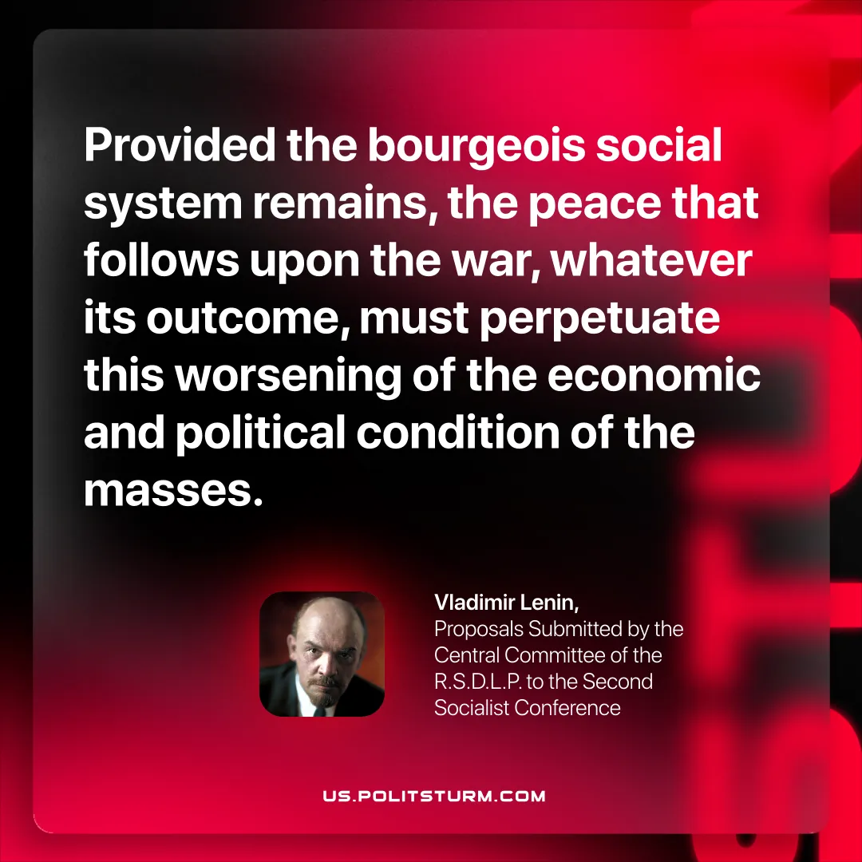

Original article
2025-11-06

“Provided the bourgeois social system remains, the peace that follows upon the war, whatever its outcome, must perpetuate this worsening of the economic and political condition of the masses.”
Vladimir Lenin, Proposals Submitted by the Central Committee of the R.S.D.L.P. to the Second Socialist Conference

Original article

