Lenin on the Aim of Opportunism for Slight Improvements
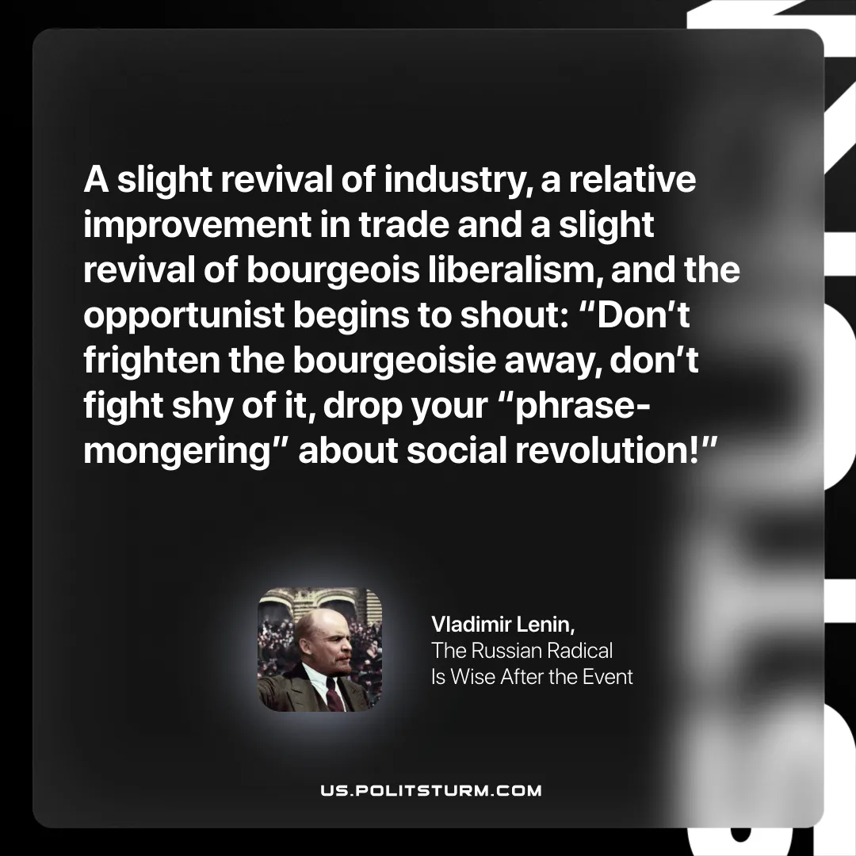

Original article
2025-10-26

“A slight revival of industry, a relative improvement in trade and a slight revival of bourgeois liberalism, and the opportunist begins to shout: Don’t frighten the bourgeoisie away, don’t fight shy of it, drop your “phrase-mongering” about social revolution!”
Vladimir Lenin, The Russian Radical Is Wise After the Event

Original article

