Lenin on the Politicians of Capitalist Society
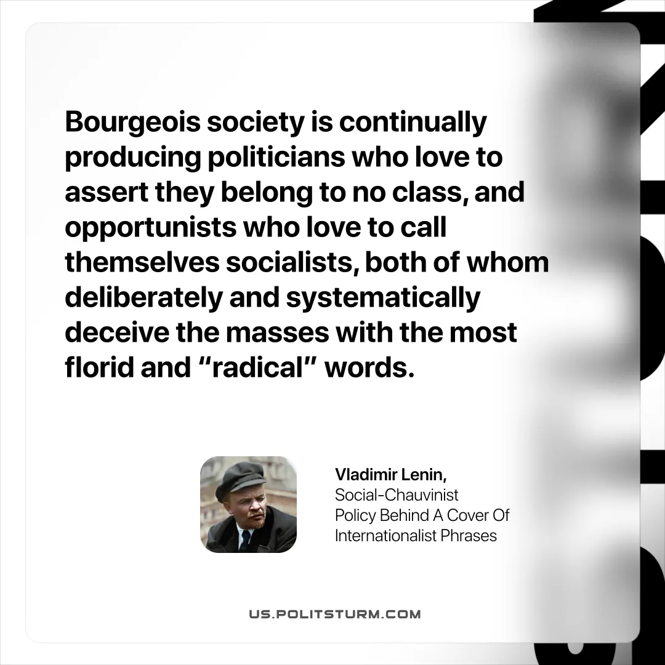

Original article
2025-10-25

“Bourgeois society is continually producing politicians who love to assert they belong to no class, and opportunists who love to call themselves socialists, both of whom deliberately and systematically deceive the masses with the most florid and “radical” words.”
Vladimir Lenin, Social-Chauvinist Policy Behind A Cover Of Internationalist Phrases

Original article

