Lenin on the Only Real Internationalism
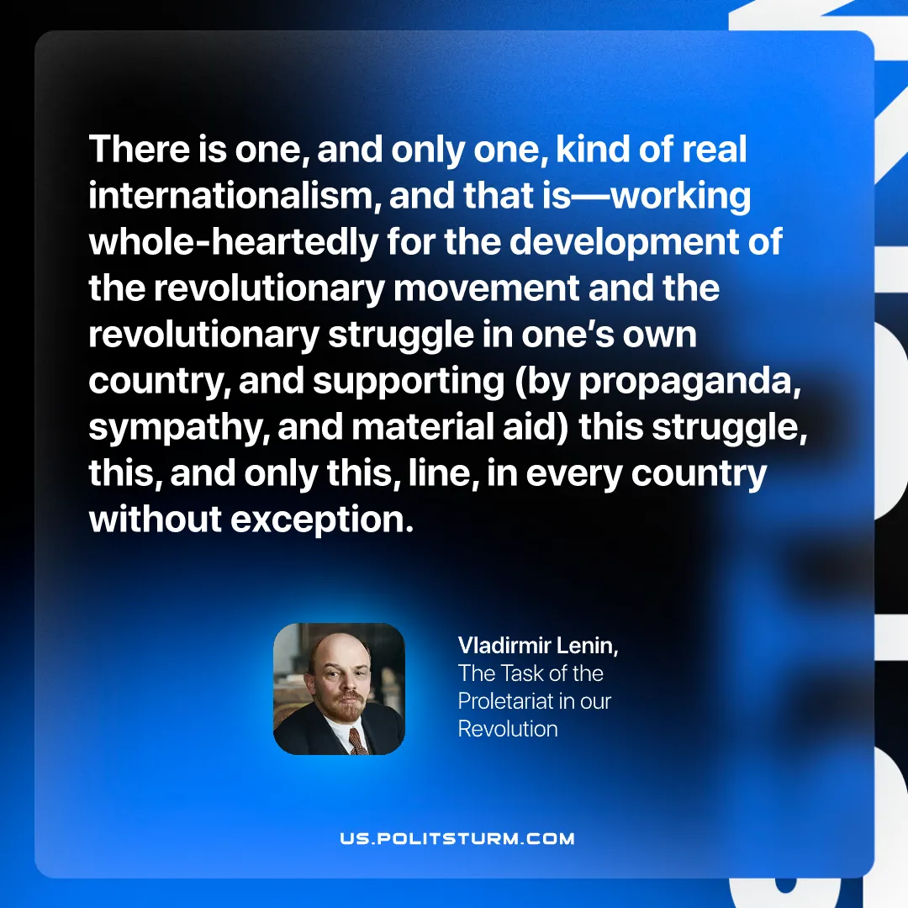

Original article
2025-09-28

“There is one, and only one, kind of real internationalism, and that is—working whole-heartedly for the development of the revolutionary movement and the revolutionary struggle in one’s own country, and supporting (by propaganda, sympathy, and material aid) this struggle, this, and only this, line, in every country without exception.”
Vladimir Lenin, The Tasks of the Proletariat in Our Revolution

Original article

