Lenin on the Future of Socialism Depending on True Internationalists
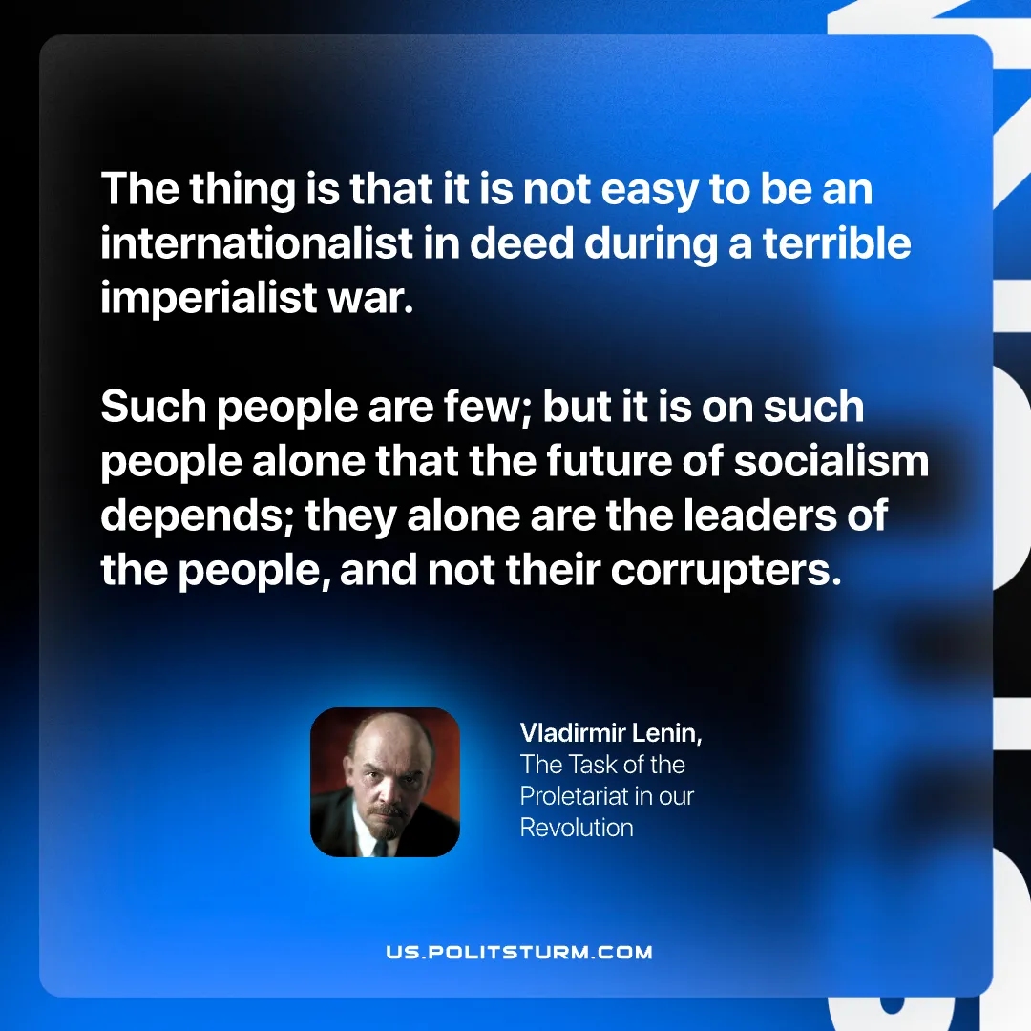

Original article
2025-09-16

“The thing is that it is not easy to be an internationalist in deed during a terrible imperialist war. Such people are few; but it is on such people alone that the future of socialism depends; they alone are the leaders of the people, and not their corrupters.”
Vladimir Lenin, The Task of the Proletariat in our Revolution

Original article

