Lenin on how Capitalist Democracy Stifles the Masses
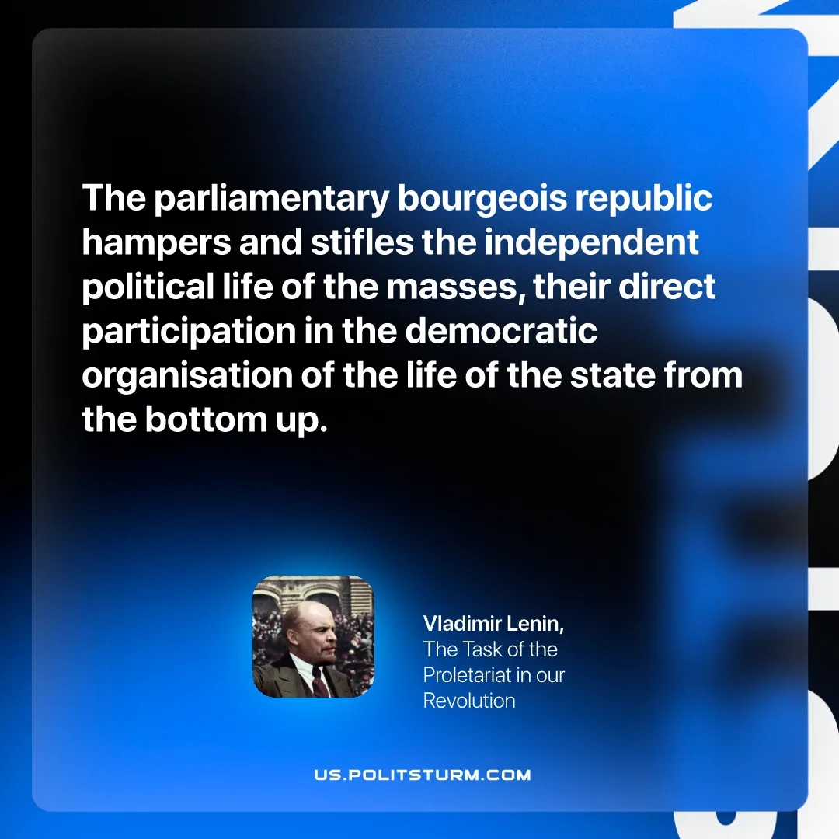

Original article
2025-08-10

“The parliamentary bourgeois republic hampers and stifles the independent political life of the masses, their direct participation in the democratic organisation of the life of the state from the bottom up.”
Vladimir Lenin, The Task of the Proletariat in our Revolution

Original article

