Lenin on the Need to Expose Ones Own Government
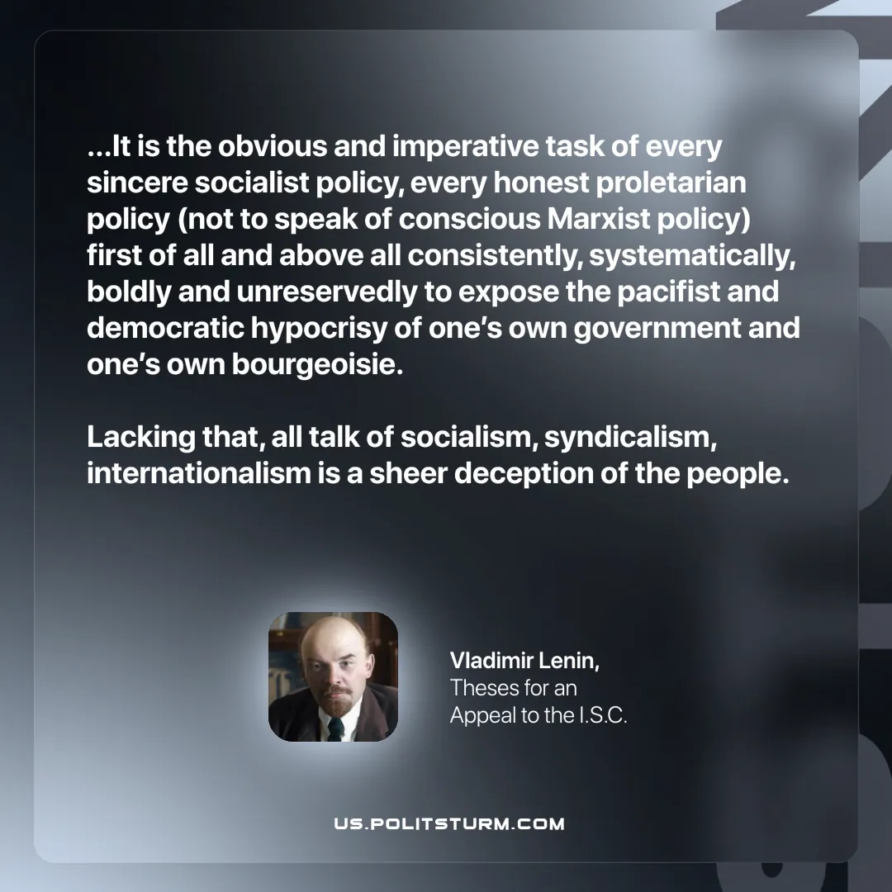

Original article
2025-07-31

“...It is the obvious and imperative task of every sincere socialist policy, every honest proletarian policy (not to speak of conscious Marxist policy) first of all and above all consistently, systematically, boldly and unreservedly to expose the pacifist and democratic hypocrisy of one’s own government and one’s own bourgeoisie. Lacking that, all talk of socialism, syndicalism, internationalism is a sheer deception of the people.
Vladimir Lenin, Theses for an Appeal to the I.S.C.

Original article

