Lenin on the Unity of Nations Against Exploitation
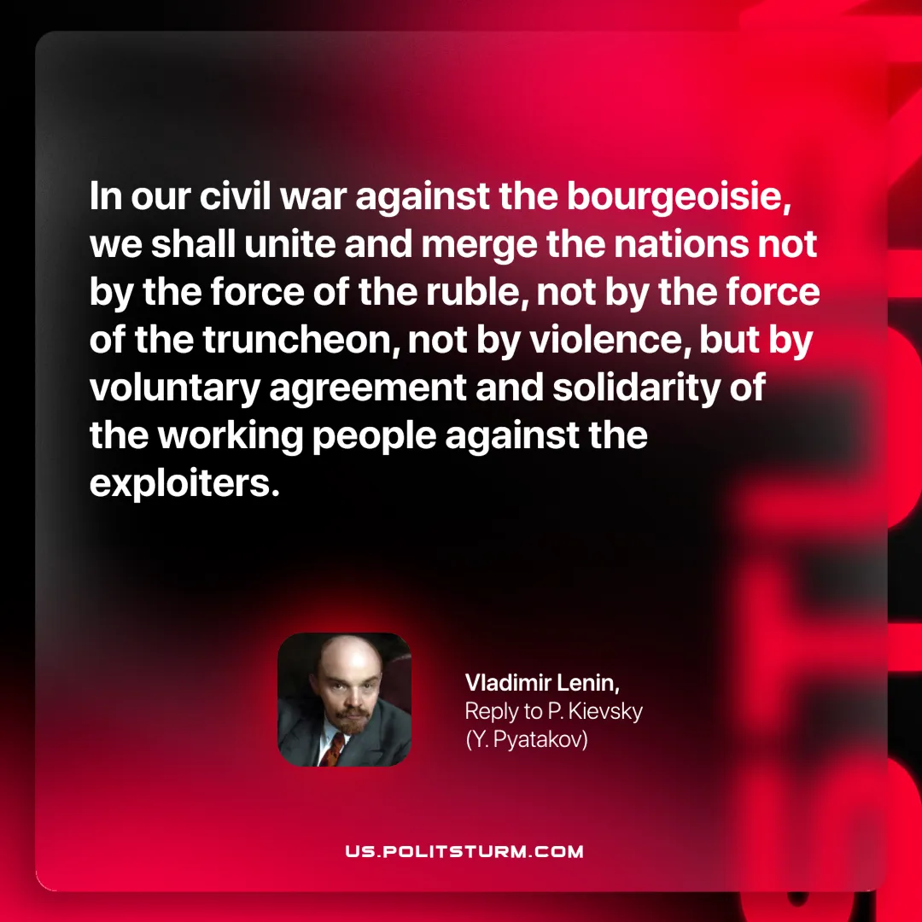

Original article
2025-07-22

“In our civil war against the bourgeoisie, we shall unite and merge the nations not by the force of the ruble, not by the force of the truncheon, not by violence, but by voluntary agreement and solidarity of the working people against the exploiters.”
Vladimir Lenin, Reply to P. Kievsky (Y. Pyatakov)

Original article

