Lenin on Repudiation of Imperialist Debts
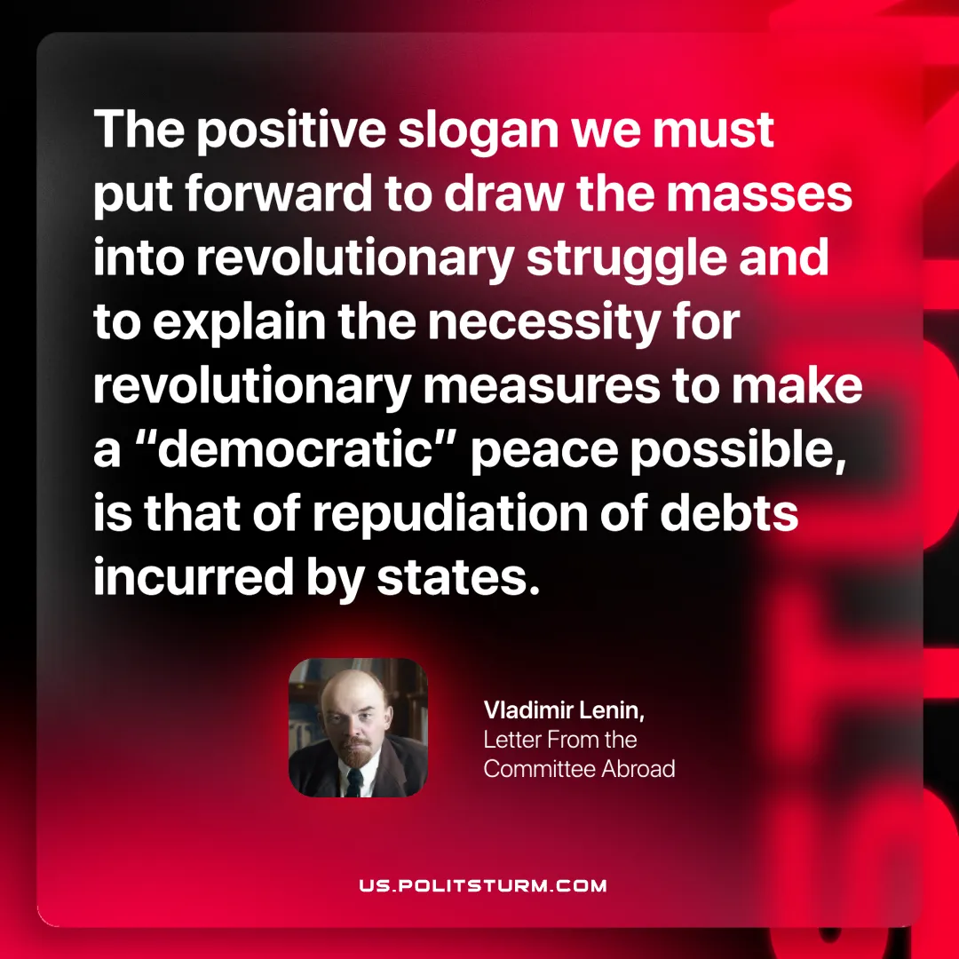

Original article
2025-07-17

“The positive slogan we must put forward to draw the masses into revolutionary struggle and to explain the necessity for revolutionary measures to make a “democratic” peace possible, is that of repudiation of debts incurred by states.”
Vladimir Lenin, Letter From the Committee Abroad

Original article

