Lenin on Socialism and Integration
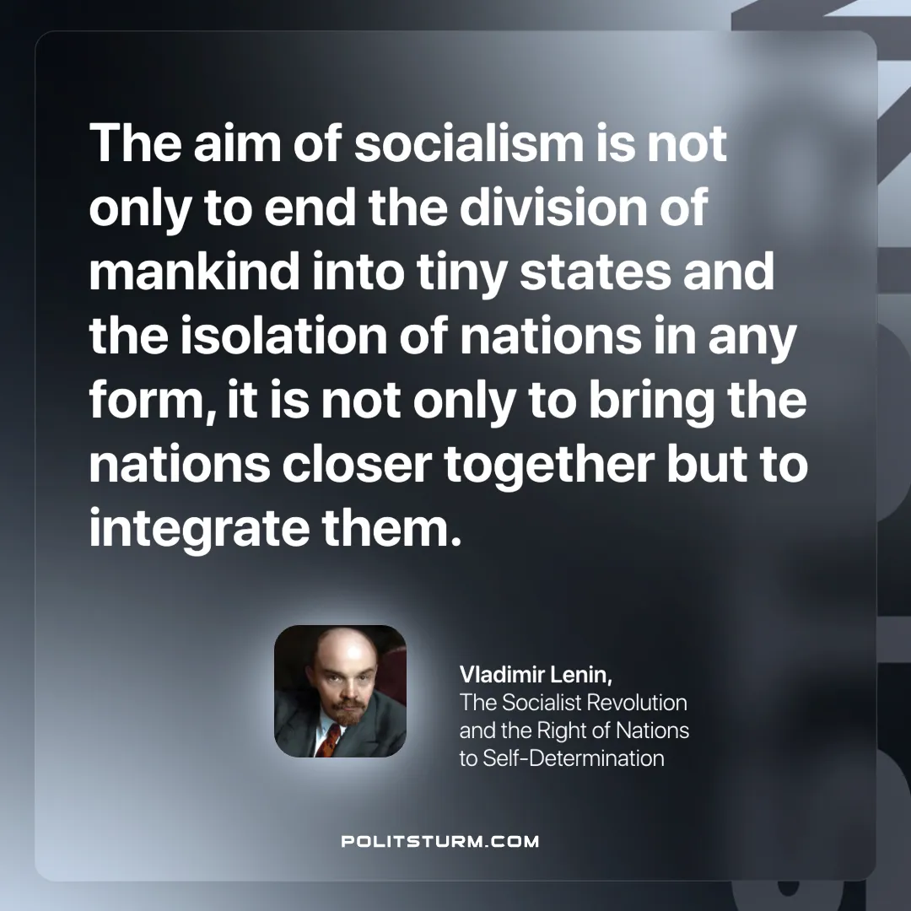

Original article
2025-06-10

"The aim of socialism is not only to end the division of mankind into tiny states and the isolation of nations in any form, it is not only to bring the nations closer together but to integrate them."
Vladimir Lenin, The Socialist Revolution and the Right of Nations to Self-Determination

Original article

