Lenin on the Real Meaning of "Defense of the Fatherland"
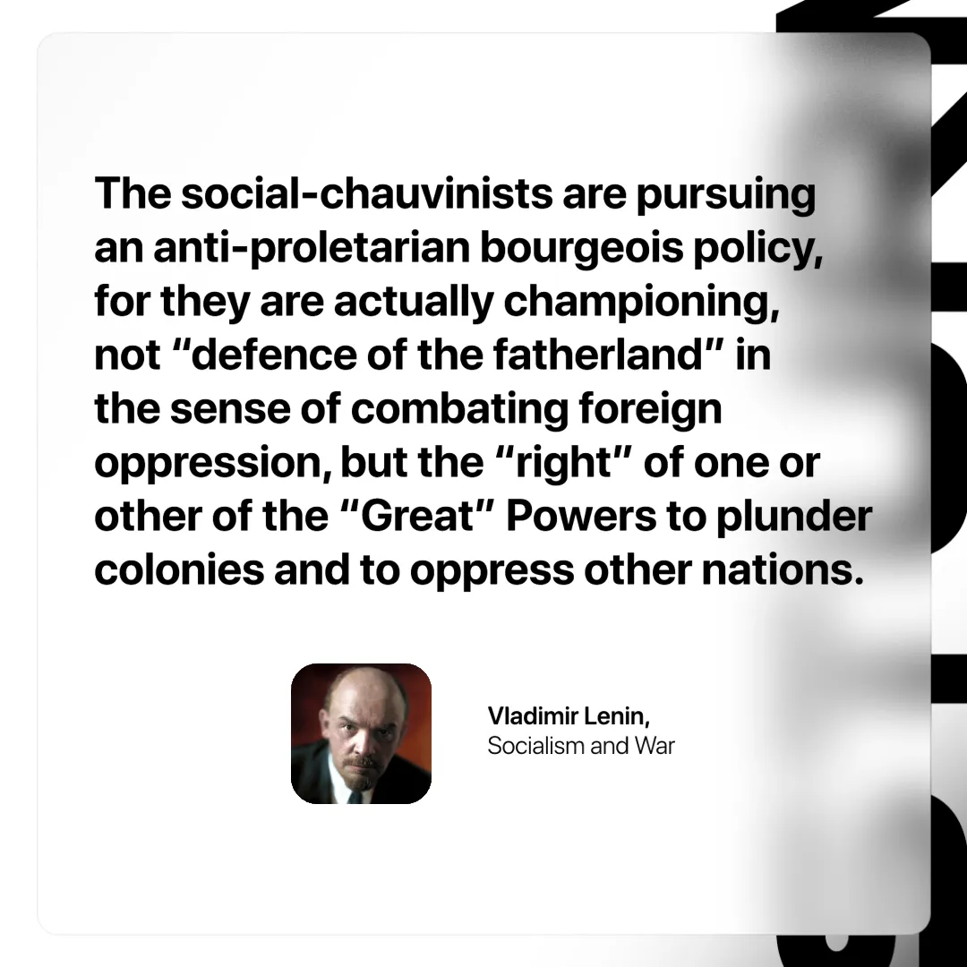

Original article
2025-04-26

“The social-chauvinists are pursuing an anti-proletarian bourgeois policy, for they are actually championing, not “defence of the fatherland” in the sense of combating foreign oppression, but the “right” of one or other of the “Great” Powers to plunder colonies and to oppress other nations.”
Vladimir Lenin, Socialism and War

Original article

