Lenin on the Need for a Theoretical and Agitational Outlet
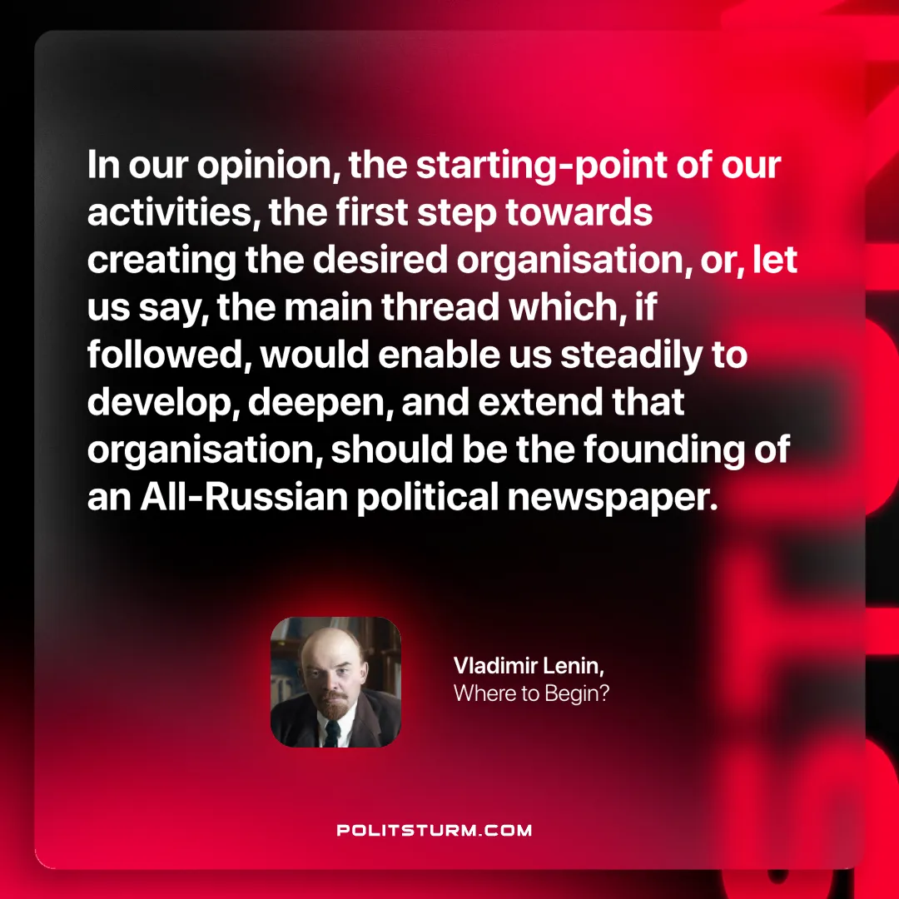

Original article
2025-01-23

“In our opinion, the starting-point of our activities, the first step towards creating the desired organisation, or, let us say, the main thread which, if followed, would enable us steadily to develop, deepen, and extend that organisation, should be the founding of an All-Russian political newspaper. ”
Vladimir Lenin, Where to Begin?

Original article

