Lenin on the Danger of Rupturing the Contact with the Masses
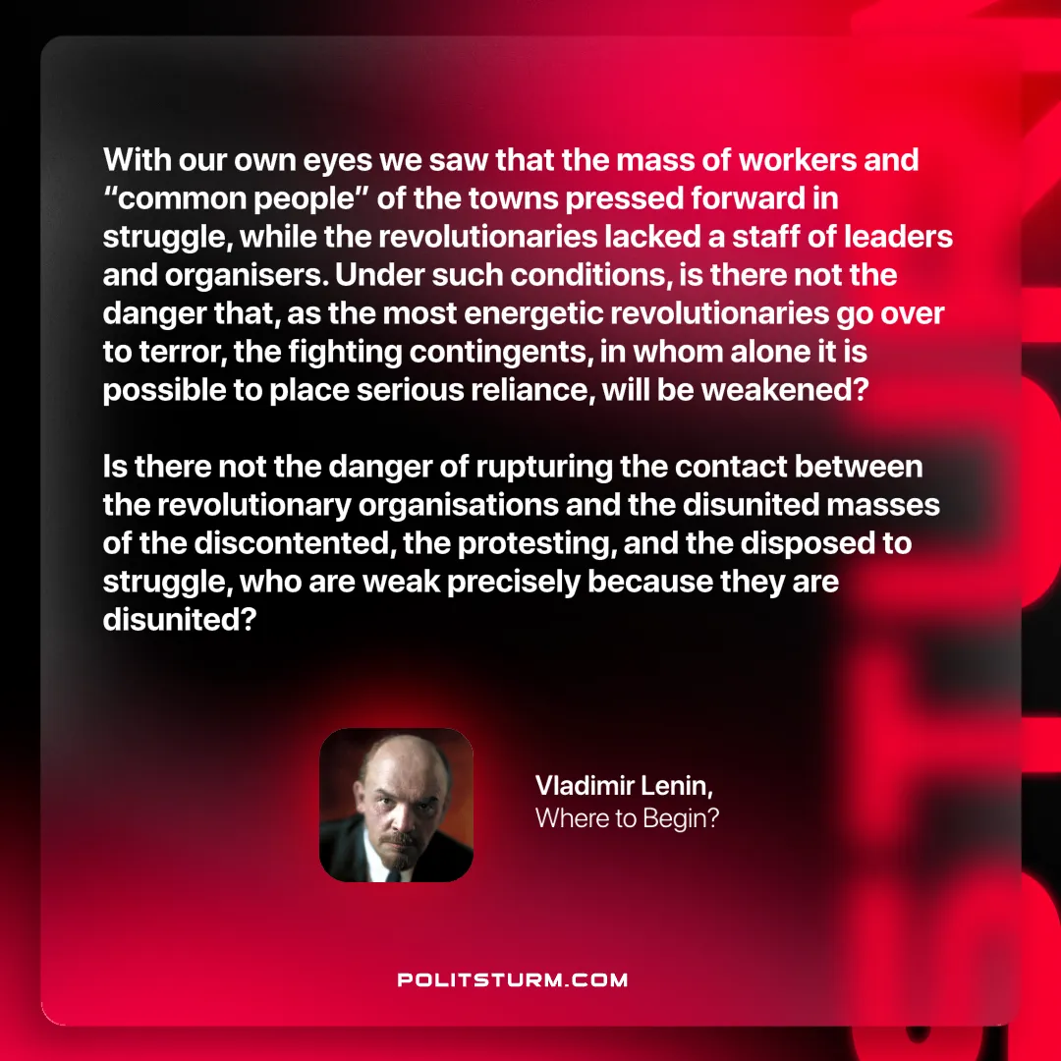

Original article
2025-01-11
1 min read

“With our own eyes we saw that the mass of workers and “common people” of the towns pressed forward in struggle, while the revolutionaries lacked a staff of leaders and organisers. Under such conditions, is there not the danger that, as the most energetic revolutionaries go over to terror, the fighting contingents, in whom alone it is possible to place serious reliance, will be weakened? Is there not the danger of rupturing the contact between the revolutionary organisations and the disunited masses of the discontented, the protesting, and the disposed to struggle, who are weak precisely because they are disunited?”
Vladimir Lenin, Where to Begin?

Original article

