Lenin on the Internationalism of the Workers
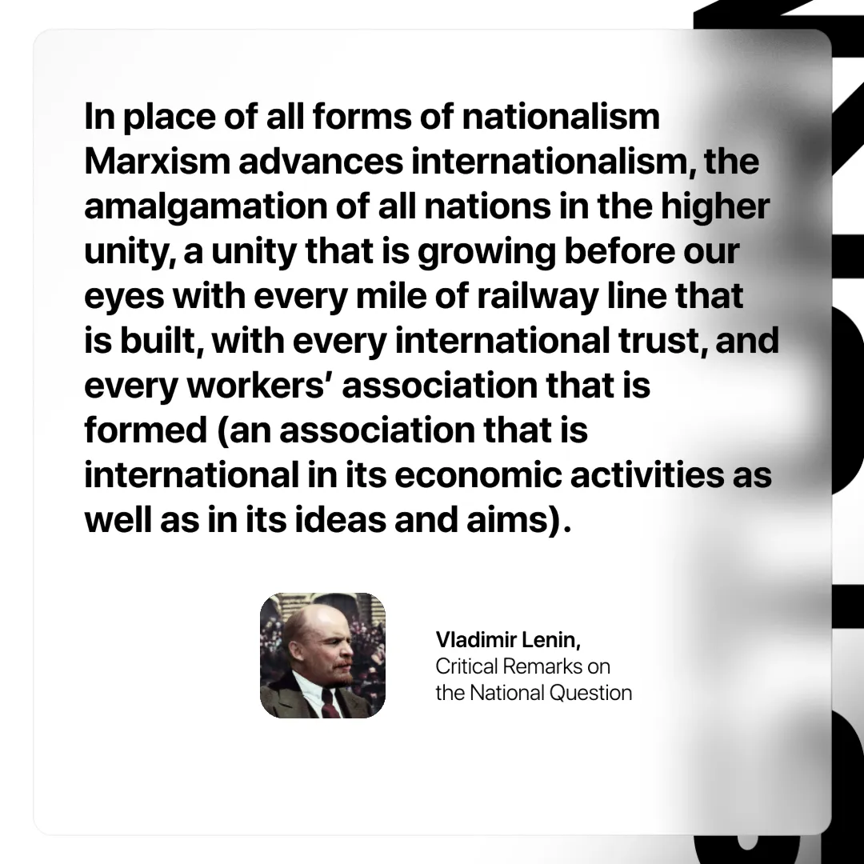

Original article
2024-12-07

“In place of all forms of nationalism Marxism advances internationalism, the amalgamation of all nations in the higher unity, a unity that is growing before our eyes with every mile of railway line that is built, with every international trust, and every workers’ association that is formed (an association that is international in its economic activities as well as in its ideas and aims).”
Vladimir Lenin, Critical Remarks on the National Question

Original article

