Lenin on Capital and the Division of the World
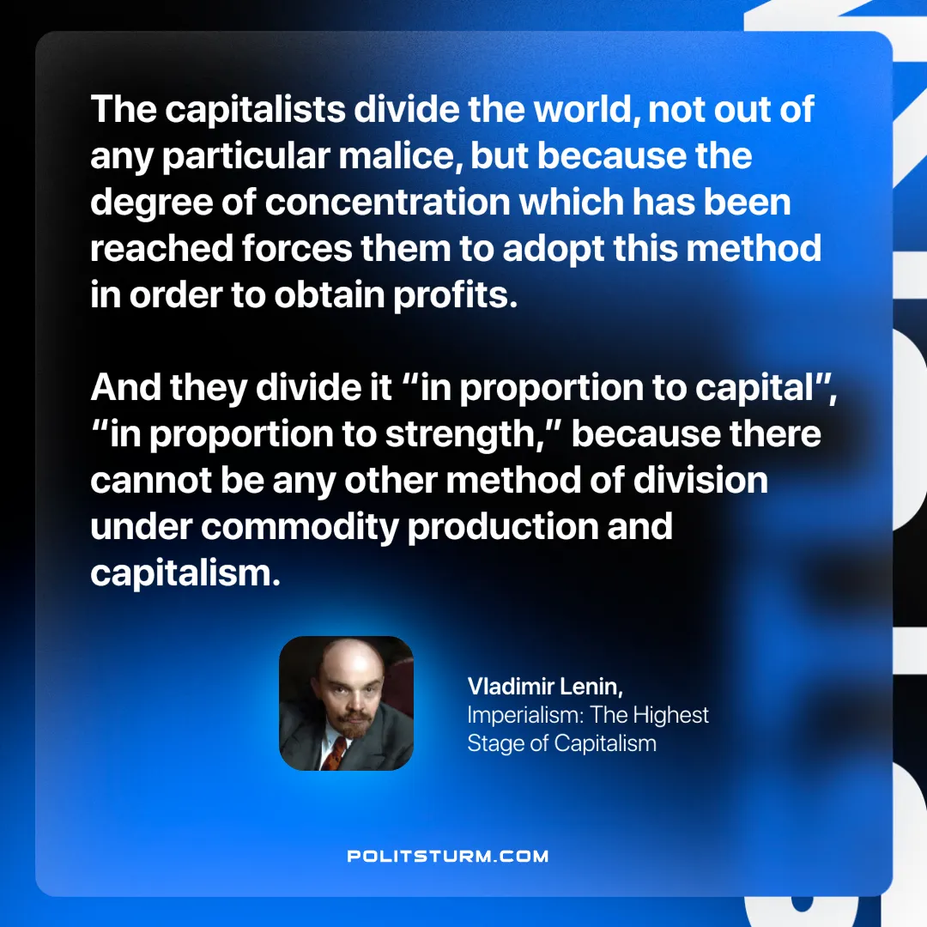

Original article
2024-11-28

“The capitalists divide the world, not out of any particular malice, but because the degree of concentration which has been reached forces them to adopt this method in order to obtain profits. And they divide it “in proportion to capital”, “in proportion to strength,” because there cannot be any other method of division under commodity production and capitalism.”
Vladimir Lenin, Imperialism: The Highest Stage of Capitalism

Original article

