Marx on the Alienation of the Worker
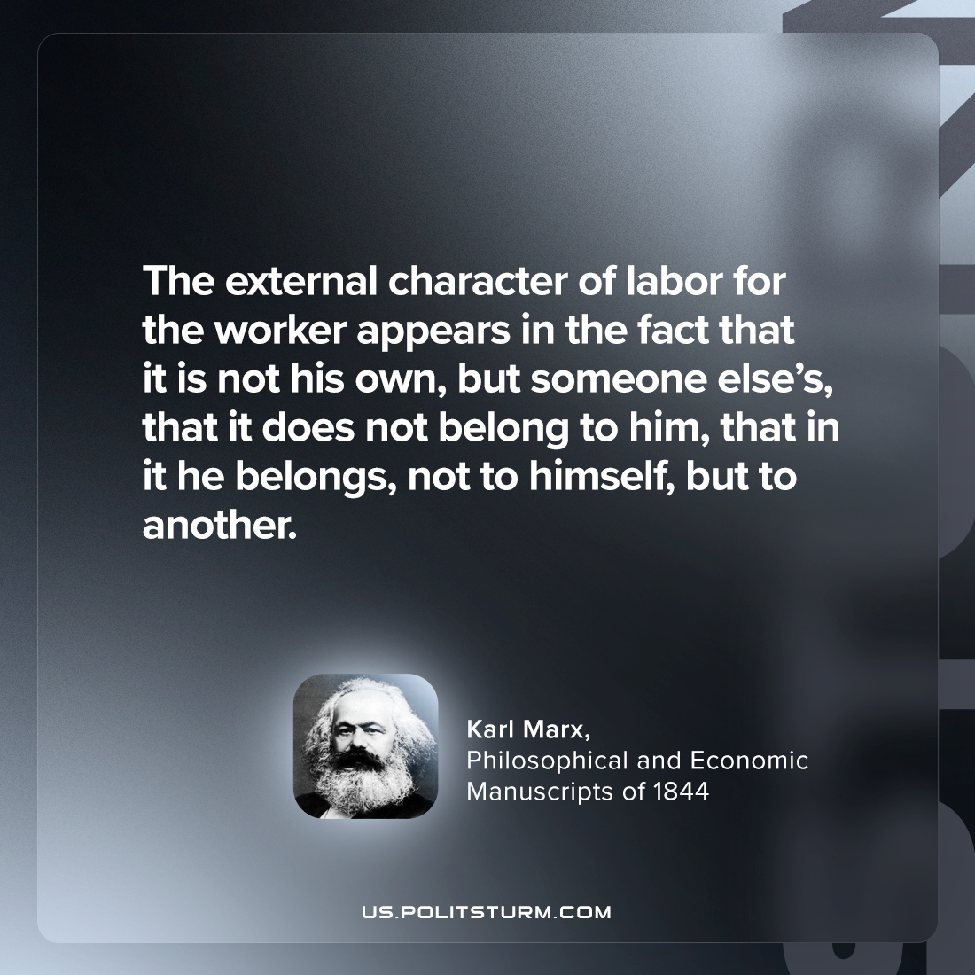

Original article
2024-06-18

"The external character of labor for the worker appears in the fact that it is not his own, but someone else’s, that it does not belong to him, that in it he belongs, not to himself, but to another."
Karl Marx, Philosophical and Economic Manuscripts of 1844

Original article

