Lenin on Unjust Criticism of Parliamentarism
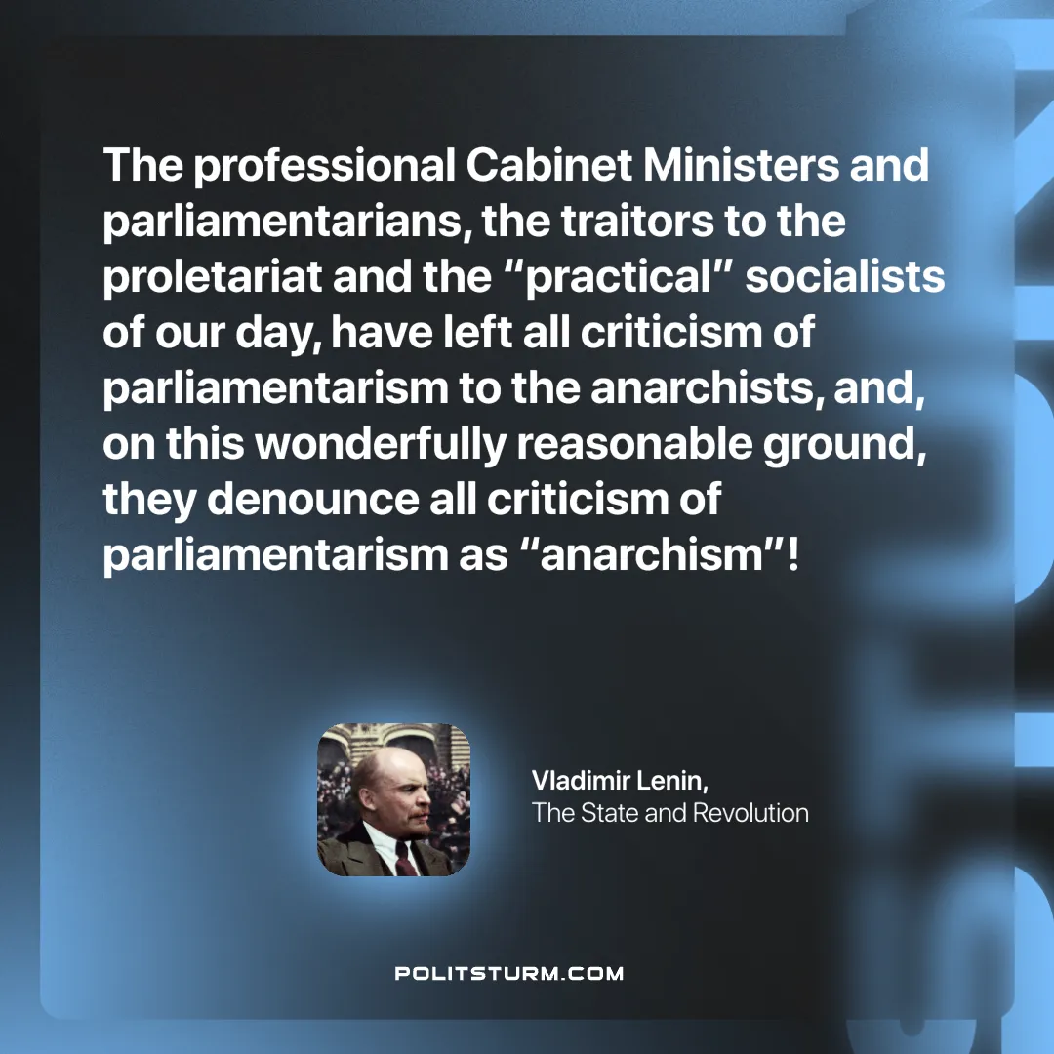

Original article
2024-11-23

“The professional Cabinet Ministers and parliamentarians, the traitors to the proletariat and the “practical” socialists of our day, have left all criticism of parliamentarism to the anarchists, and, on this wonderfully reasonable ground, they denounce all criticism of parliamentarism as “anarchism”!”
Vladimir Lenin, The State and Revolution

Original article

