Lenin on Wage Slavery and Bourgeois Democracy
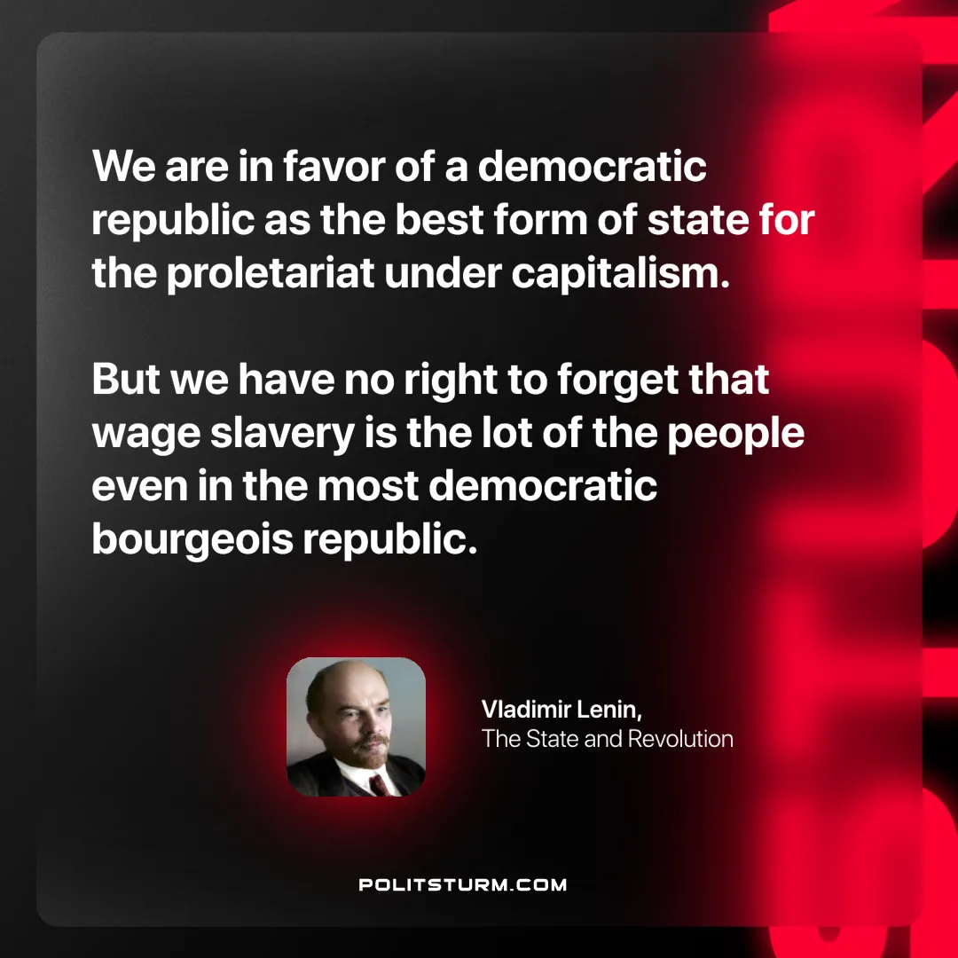

Original article
2024-11-19

“We are in favor of a democratic republic as the best form of state for the proletariat under capitalism. But we have no right to forget that wage slavery is the lot of the people even in the most democratic bourgeois republic.”
Vladimir Lenin, The State and Revolution

Original article

