Lenin on Oppressor Nations Recognizing Equality for the Oppressed
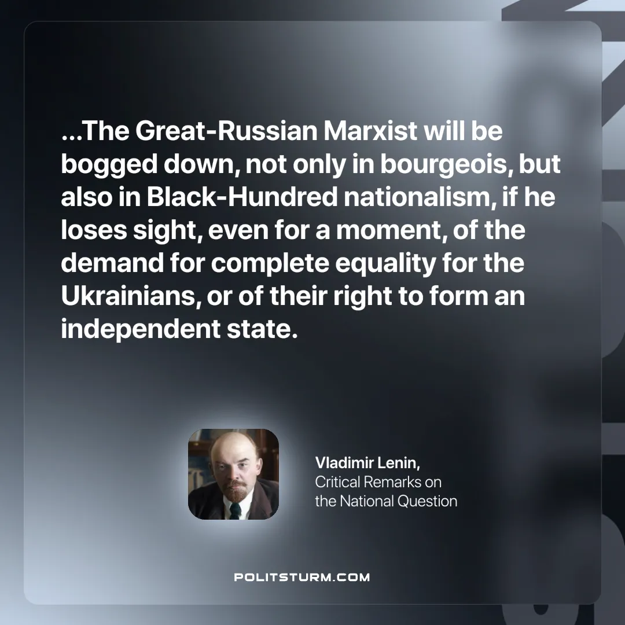

Original article
2024-10-12

…The Great-Russian Marxist will be bogged down, not only in bourgeois, but also in Black-Hundred nationalism, if he loses sight, even for a moment, of the demand for complete equality for the Ukrainians, or of their right to form an independent state.
Vladimir Lenin, Critical Remarks on the National Question.

Original article

