Lenin of the Division Between Workers of Different Nations
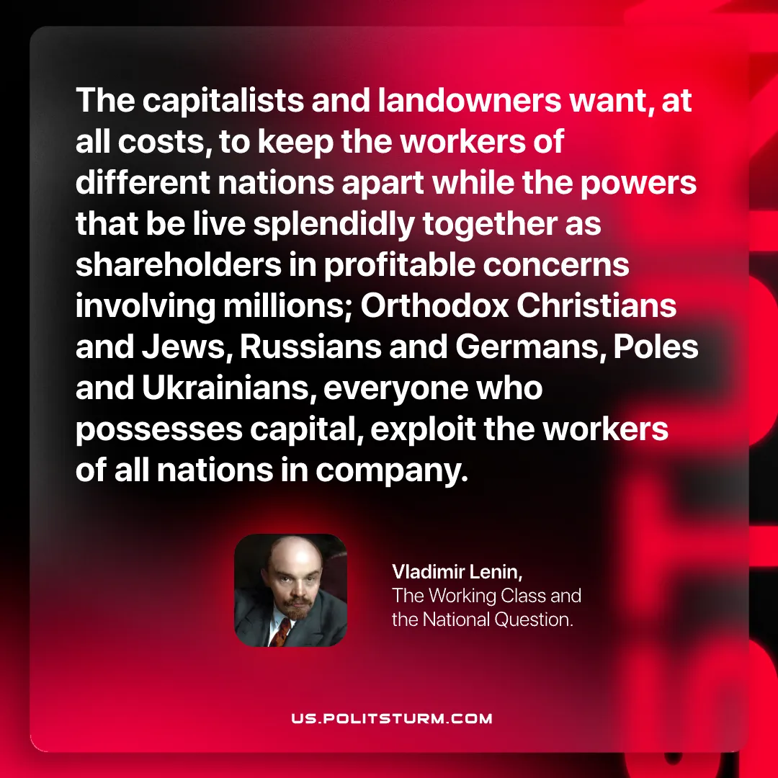

Original article
2026-07-21

The capitalists and landowners want, at all costs, to keep the workers of different nations apart while the powers that be live splendidly together as shareholders in profitable concerns involving millions; Orthodox Christians and Jews, Russians and Germans, Poles and Ukrainians, everyone who possesses capital, exploit the workers of all nations in company.
Vladimir Lenin, The Working Class and the National Question.

Original article

