Lenin on the Need for an Independent Proletarian Policy
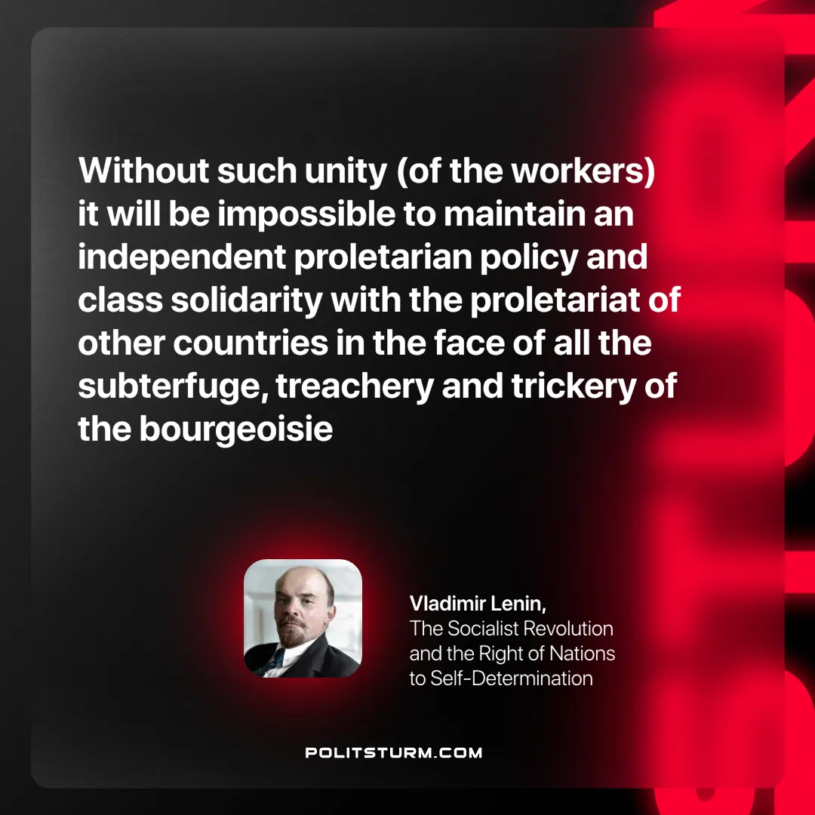

Original article
2024-10-01

“Without [such] unity it will be impossible to maintain an independent proletarian policy and class solidarity with the proletariat of other countries in the face of all the subterfuge, treachery and trickery of the bourgeoisie”
Vladimir Lenin, The Socialist Revolution and the Right of Nations to Self-Determination.

Original article

