Lenin on Opportunist Trends Reiterating Chauvinist Slogans
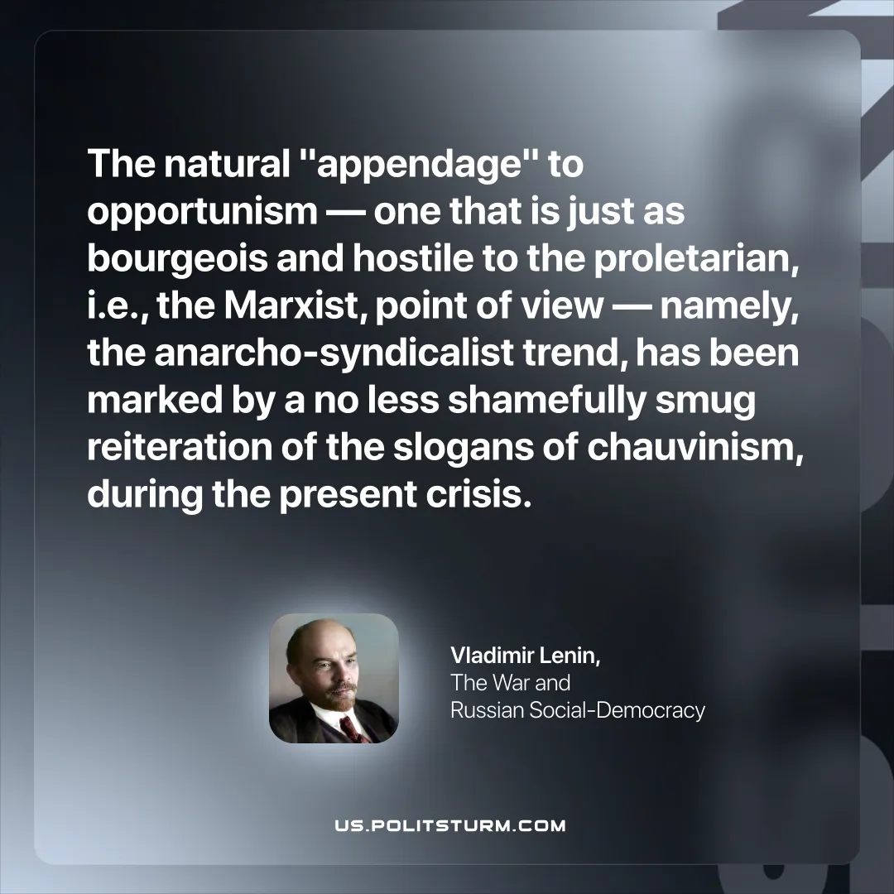

Original article
2025-10-30

"The natural "appendage" to opportunism — one that is just as bourgeois and hostile to the proletarian, i.e., the Marxist, point of view — namely, the anarcho-syndicalist trend, has been marked by a no less shamefully smug reiteration of the slogans of chauvinism, during the present crisis."
Vladimir Lenin, The War and Russian Social-Democracy

Original article

