Lenin on Freedom of the Press Under Capitalism
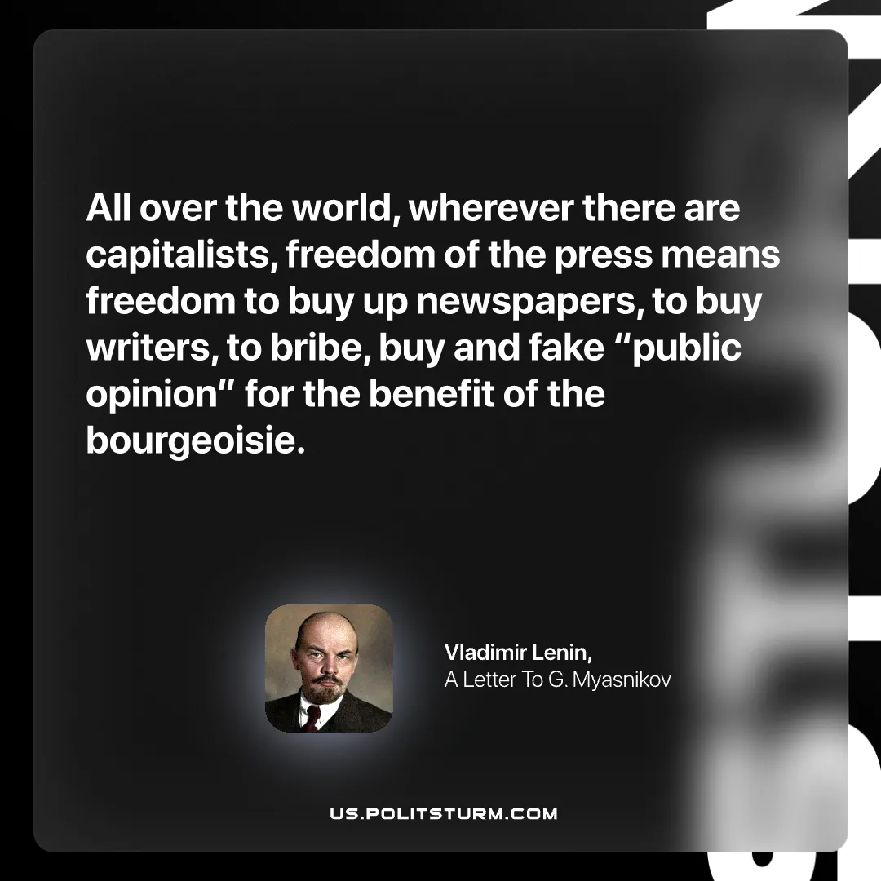

Original article
2025-08-21

“All over the world, wherever there are capitalists, freedom of the press means freedom to buy up newspapers, to buy writers, to bribe, buy and fake “public opinion” for the benefit of the bourgeoisie.”
Vladimir Lenin, A Letter To G. Myasnikov

Original article

