Lenin on the Opportunist System of Deception
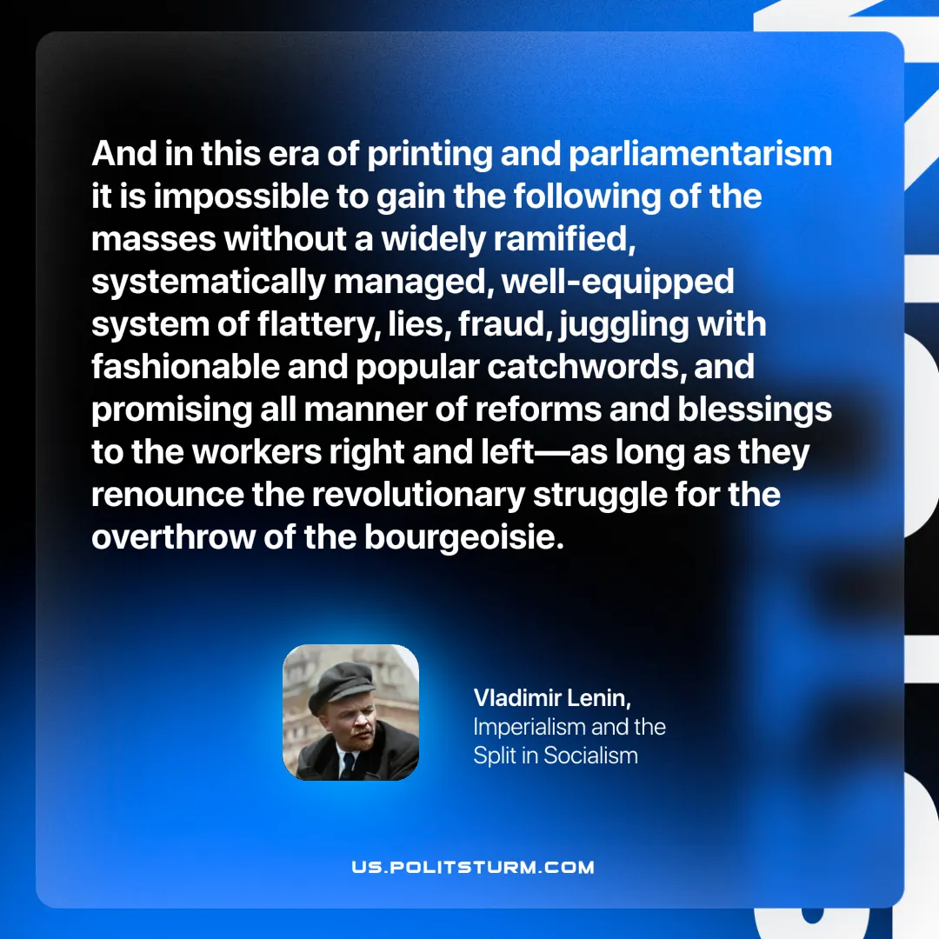

Original article
2025-07-29

“And in this era of printing and parliamentarism it is impossible to gain the following of the masses without a widely ramified, systematically managed, well-equipped system of flattery, lies, fraud, juggling with fashionable and popular catchwords, and promising all manner of reforms and blessings to the workers right and left—as long as they renounce the revolutionary struggle for the overthrow of the bourgeoisie.”
Vladimir Lenin, Imperialism and the Split in Socialism

Original article

