Lenin Exposing the Class Gulf
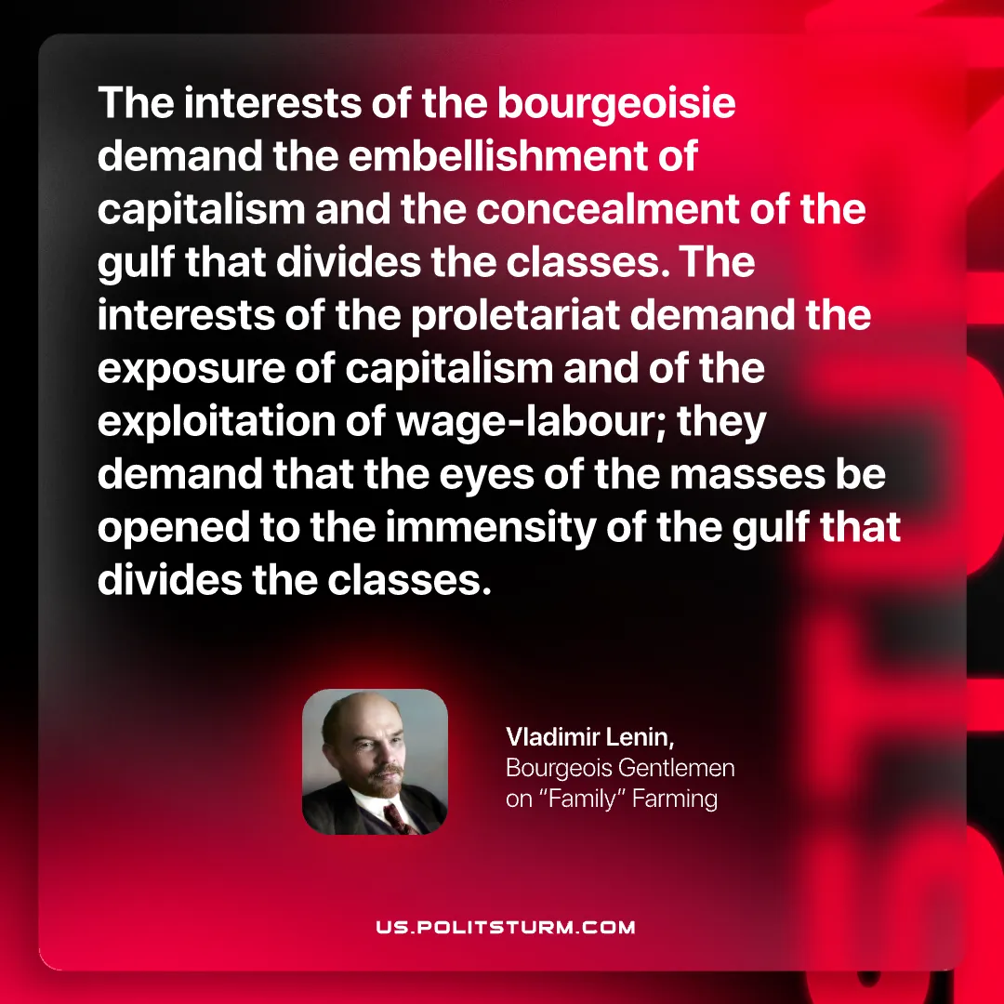

Original article
2026-08-27

The interests of the bourgeoisie demand the embellishment of capitalism and the concealment of the gulf that divides the classes. The interests of the proletariat demand the exposure of capitalism and of the exploitation of wage-labour; they demand that the eyes of the masses be opened to the immensity of the gulf that divides the classes.
Vladimir Lenin, Bourgeois Gentlemen on "Family" Farming

Original article

