Lenin Against Any And All Bourgeois Ideology
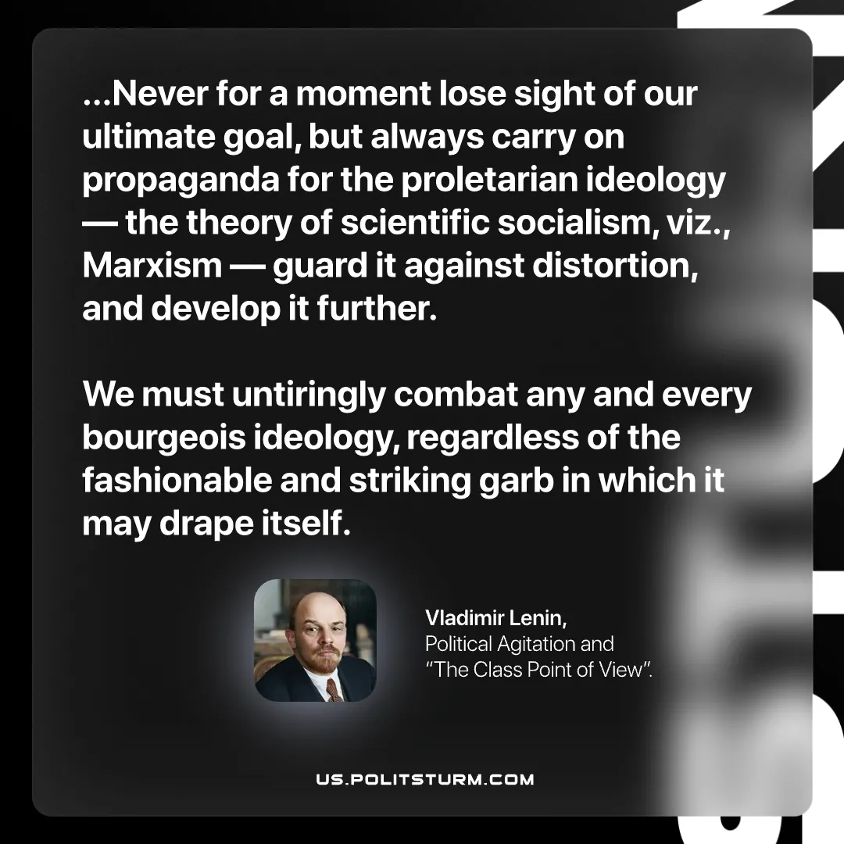

Original article
2026-06-25

…Never for a moment lose sight of our ultimate goal, but always carry on propaganda for the proletarian ideology — the theory of scientific socialism, viz., Marxism — guard it against distortion, and develop it further.
We must untiringly combat any and every bourgeois ideology, regardless of the fashionable and striking garb in which it may drape itself.
Vladimir Lenin, Political Agitation and “The Class Point of View”.

Original article

