Lenin — 150th Anniversary
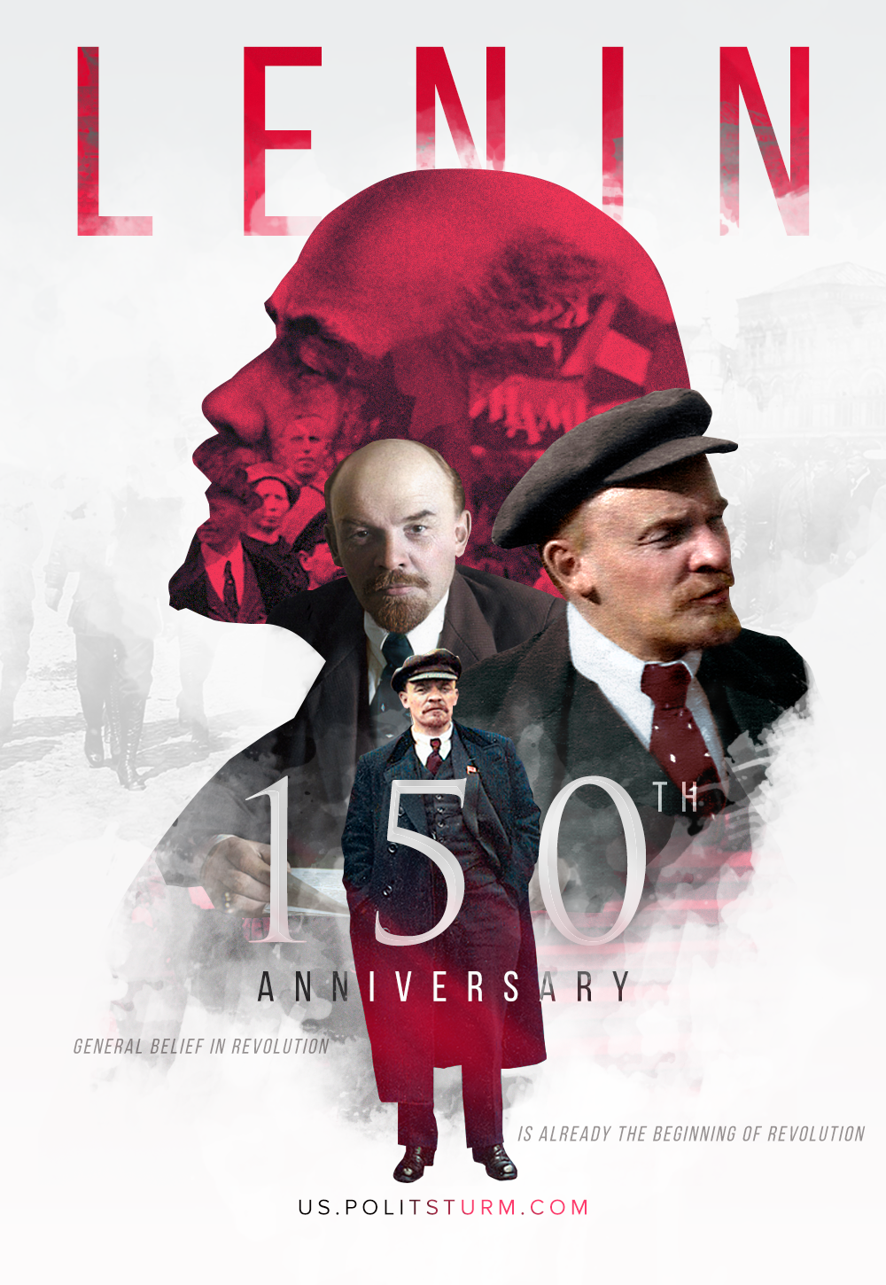

Original article
2020-04-22

150 years ago, on April 22, 1870, Vladimir Ilyich Lenin was born. He was the leader of the world proletariat, the founder of the Soviet state, a revolutionary and the great theoretician of Marxism.
“General belief in revolution is already the beginning of the revolution”.

Original article

