Lenin on the Development of Opportunism
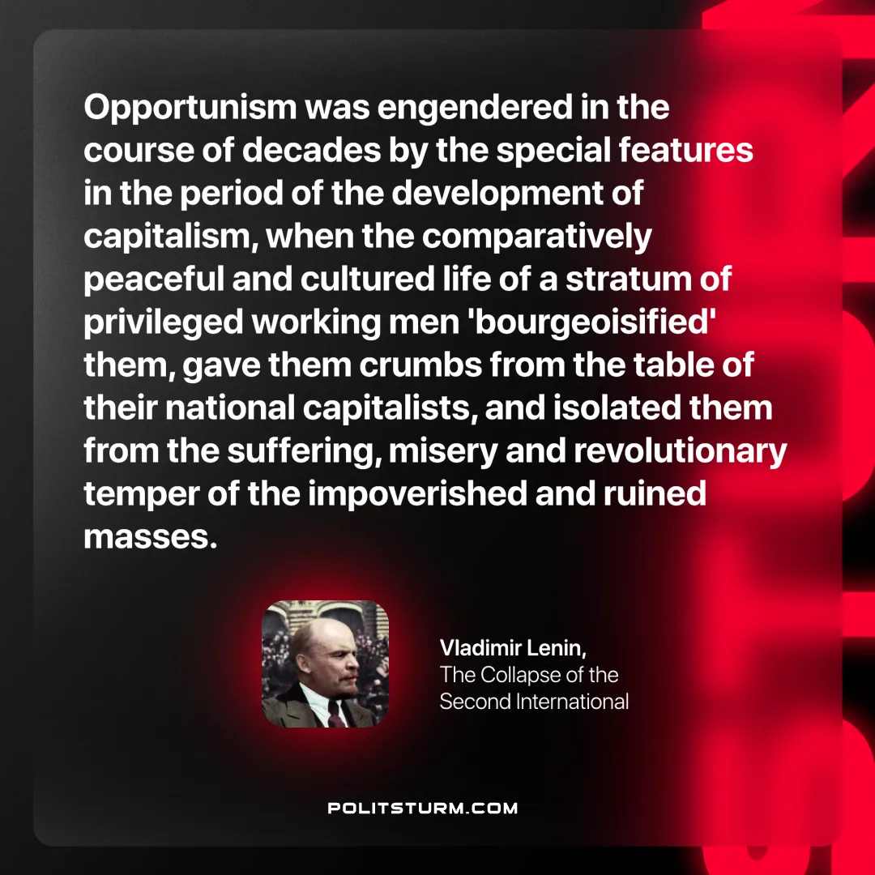

Original article
2025-05-04

"Opportunism was engendered in the course of decades by the special features in the period of the development of capitalism, when the comparatively peaceful and cultured life of a stratum of privileged working men 'bourgeoisified' them, gave them crumbs from the table of their national capitalists, and isolated them from the suffering, misery and revolutionary temper of the impoverished and ruined masses."
Vladimir Lenin, The Collapse of the Second International

Original article

