Lenin on Liberal Leadership in the Movement
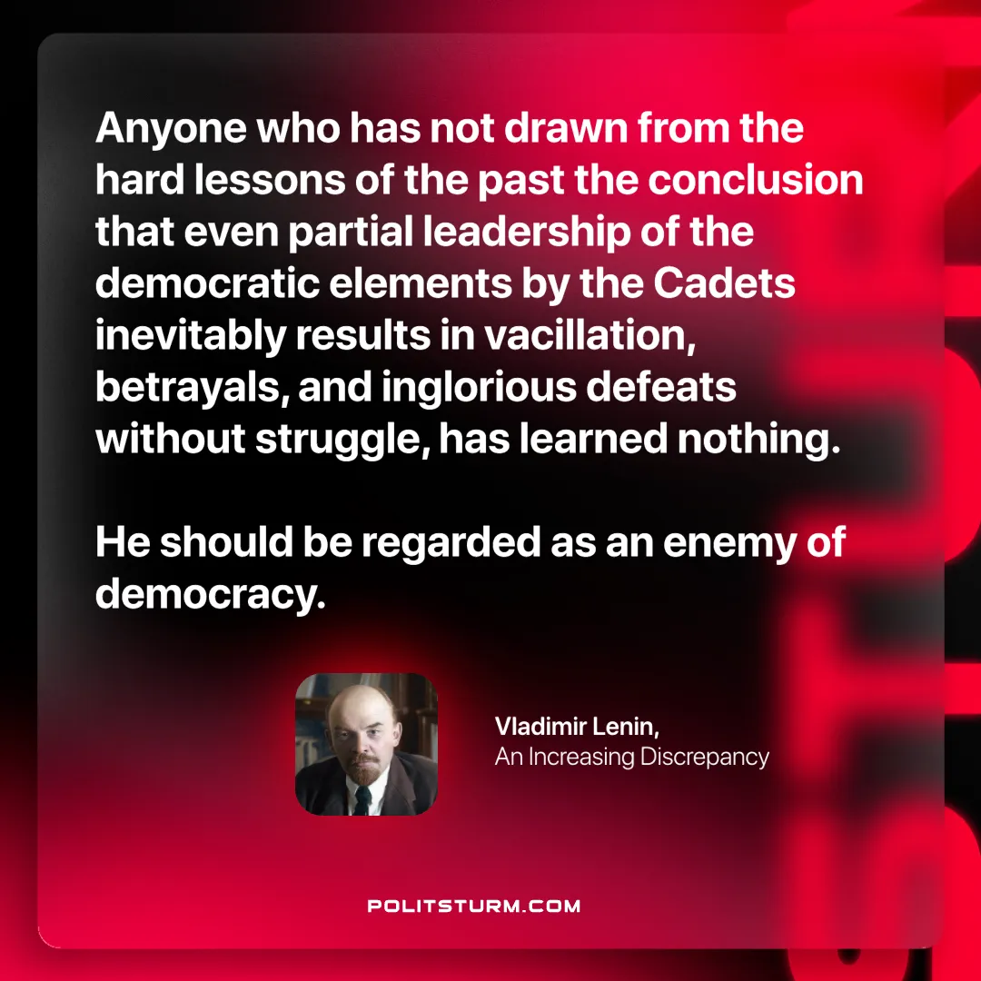

Original article
2025-02-25

"Anyone who has not drawn from the hard lessons of the past the conclusion that even partial leadership of the democratic elements by the Cadets inevitably results in vacillation, betrayals, and inglorious defeats without struggle, has learned nothing. He should be regarded as an enemy of democracy."
Vladimir Lenin, An Increasing Discrepancy

Original article

