Lenin on the Deceptive Nature of a Democratic Peace Under Imperialism
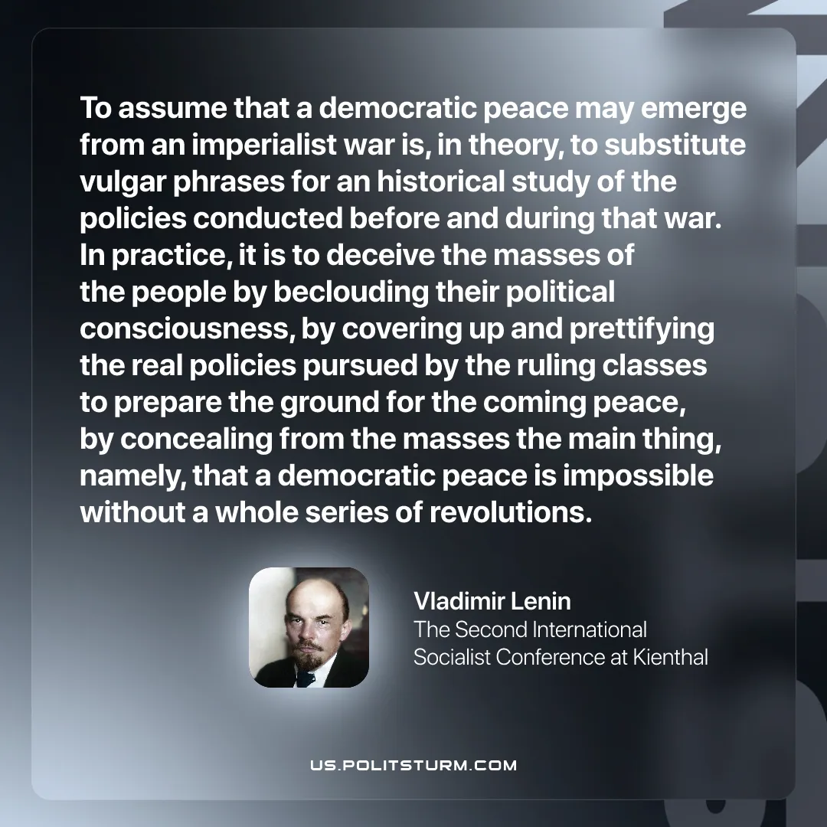

Original article
2025-12-20
1 min read

“To assume that a democratic peace may emerge from an imperialist war is, in theory, to substitute vulgar phrases for an historical study of the policies conducted before and during that war. In practice, it is to deceive the masses of the people by beclouding their political consciousness, by covering up and prettifying the real policies pursued by the ruling classes to prepare the ground for the coming peace, by concealing from the masses the main thing, namely, that a democratic peace is impossible without a whole series of revolutions.”
Vladimir Lenin, Proposals Submitted by the Central Committee of the R.S.D.L.P. to the Second Socialist Conference

Original article

