Lenin on Societal Decay Collapsing During War
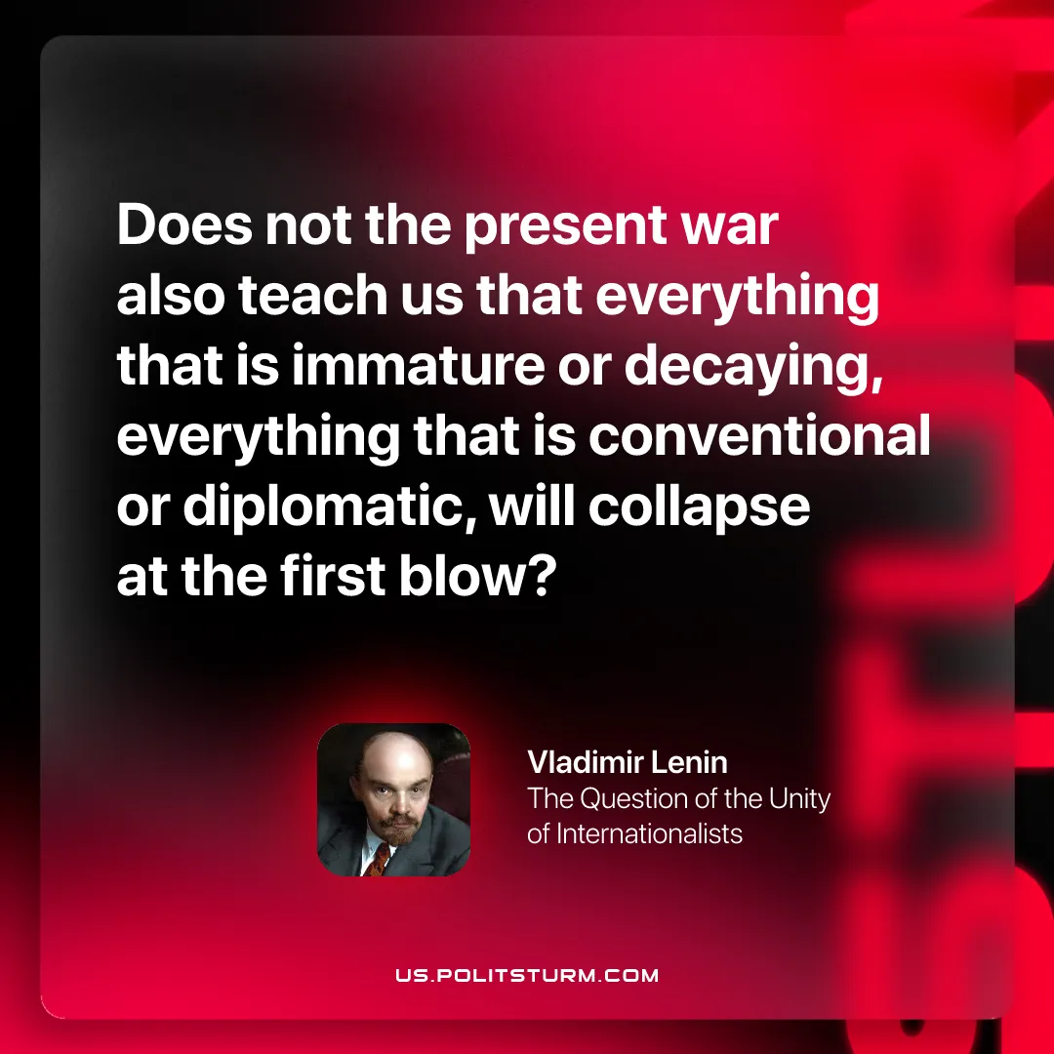

Original article
2025-12-16

Does not the present war also teach us that everything that is immature or decaying, everything that is conventional or diplomatic, will collapse at the first blow?
Vladimir Lenin, The Question Of The Unity Of Internationalists

Original article

