Lenin on Communists Engaging in Concrete Analysis of the Situation
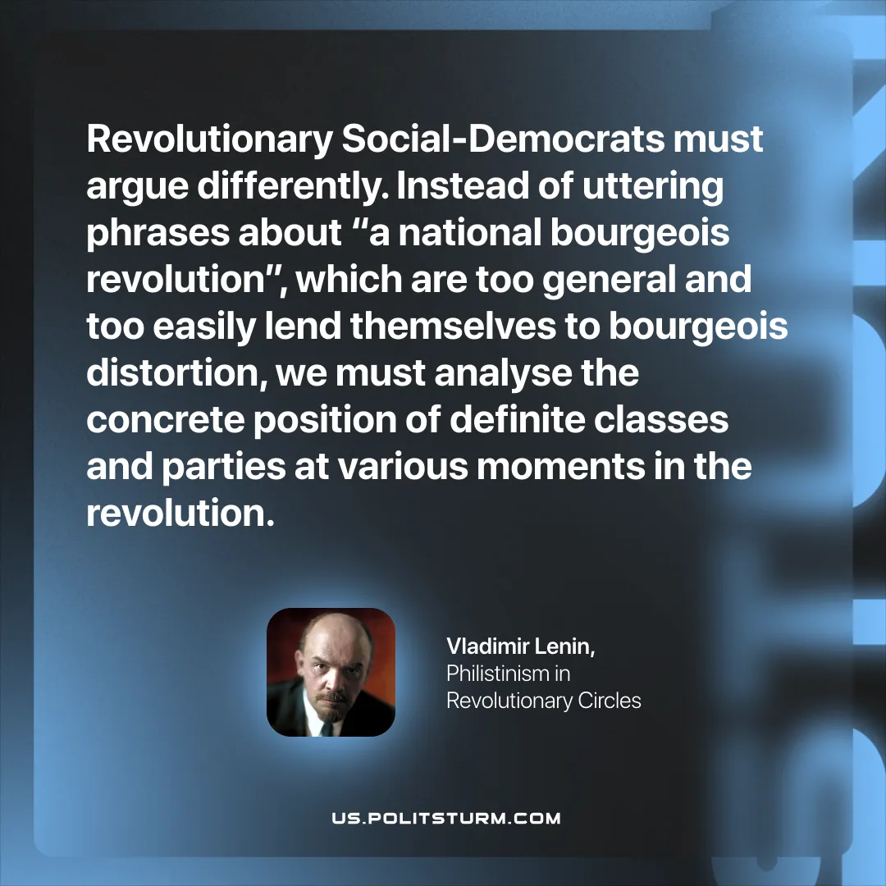

Original article
2025-12-04

“Revolutionary Social-Democrats must argue differently. Instead of uttering phrases about “a national bourgeois revolution”, which are too general and too easily lend themselves to bourgeois distortion, we must analyse the concrete position of definite classes and parties at various moments in the revolution.”
Vladimir Lenin, Philistinism in Revolutionary Circles

Original article

