Lenin on Wars Being the Tester of Capitalist Might
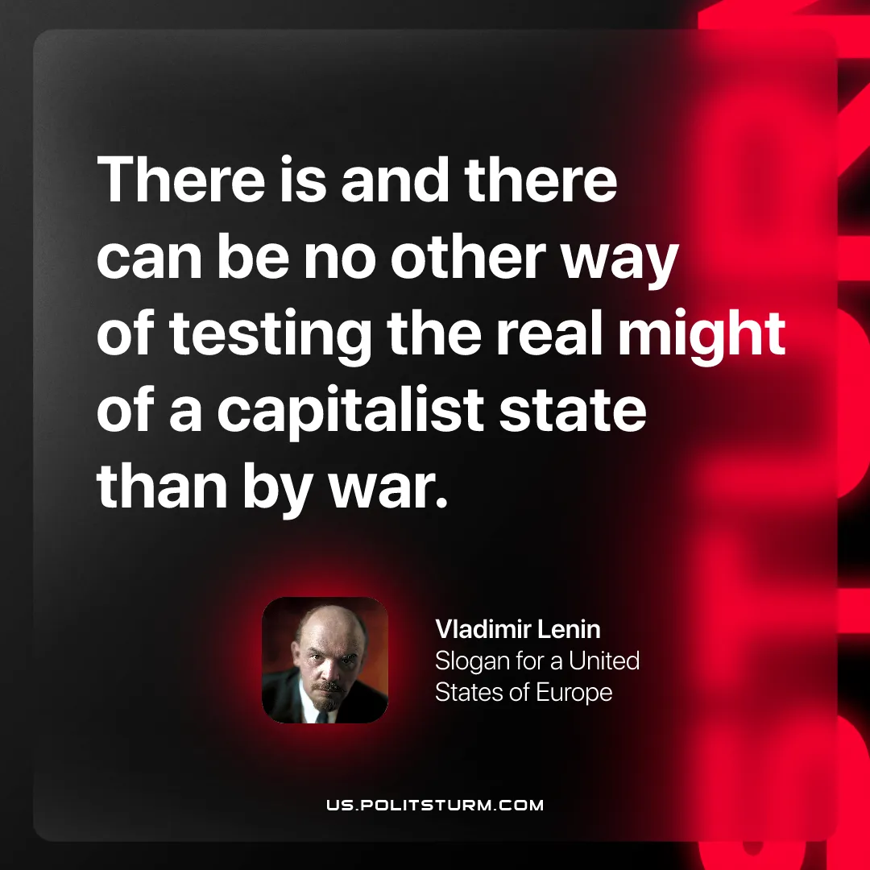

Original article
2025-12-14

There is and there can be no other way of testing the real might of a capitalist state than by war.
Vladimir Lenin, Slogan For A United States Of Europe

Original article

