Lenin on Organization Without Principles
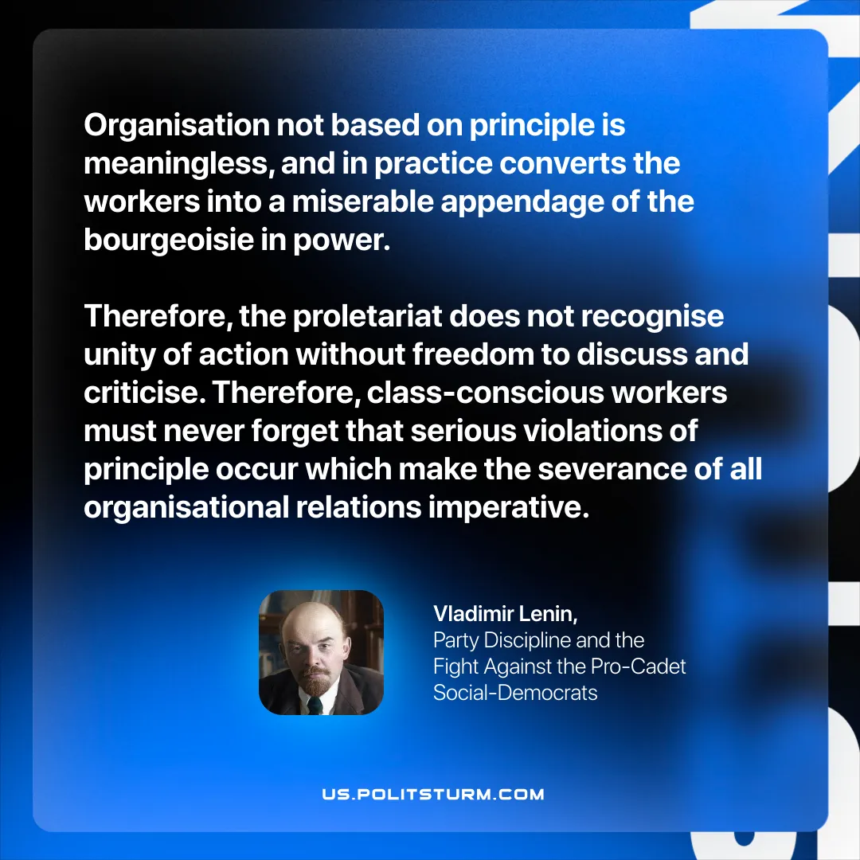

Original article
2025-10-28

“Organisation not based on principle is meaningless, and in practice converts the workers into a miserable appendage of the bourgeoisie in power. Therefore, the proletariat does not recognise unity of action without freedom to discuss and criticise. Therefore, class-conscious workers must never forget that serious violations of principle occur which make the severance of all organisational relations imperative.”
Vladimir Lenin, Party Discipline and the Fight Against the Pro-Cadet Social-Democrats

Original article

