Lenin on the Class Character of War
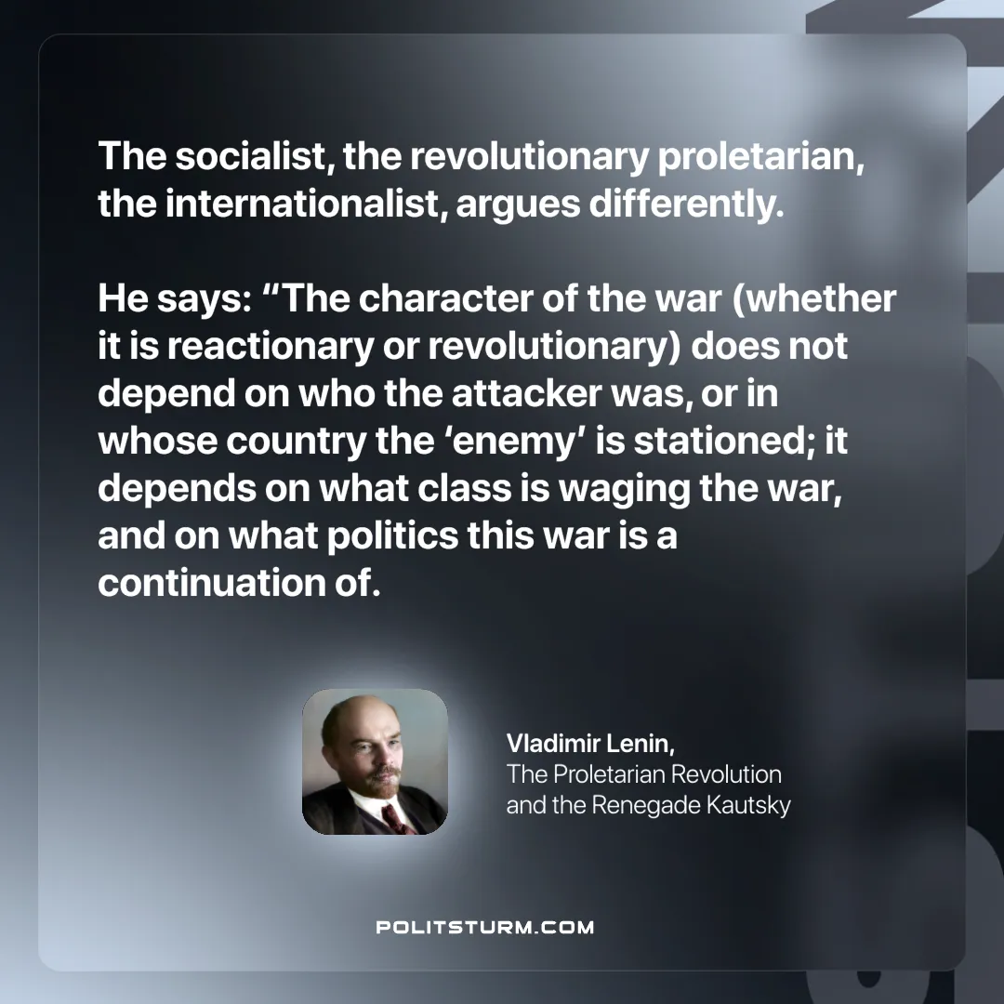

Original article
2024-12-12

“The socialist, the revolutionary proletarian, the internationalist, argues differently. He says: “The character of the war (whether it is reactionary or revolutionary) does not depend on who the attacker was, or in whose country the ‘enemy’ is stationed; it depends on what class is waging the war, and on what politics this war is a continuation of.”
Vladimir Lenin, The Proletarian Revolution and the Renegade Kautsky

Original article

