Lenin on the Idea of 'Peace' Under Capitalism
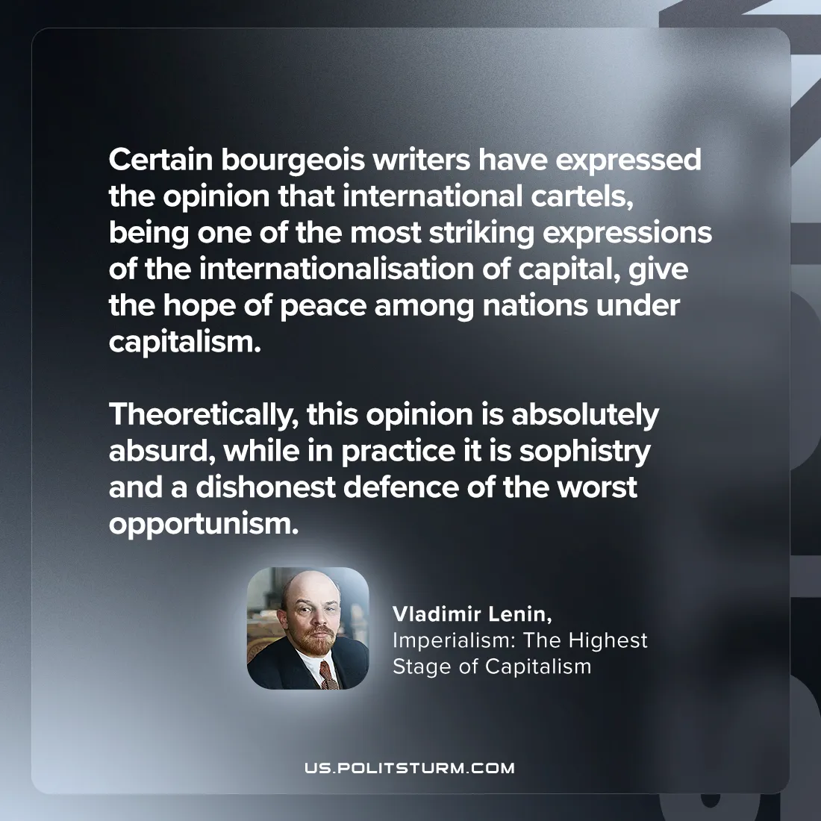

Original article
2024-09-05

"Certain bourgeois writers have expressed the opinion that international cartels, being one of the most striking expressions of the internationalisation of capital, give the hope of peace among nations under capitalism. Theoretically, this opinion is absolutely absurd, while in practice it is sophistry and a dishonest defence of the worst opportunism.”
Vladimir Lenin, Imperialism: The Highest Stage of Capitalism

Original article

