Lenin on the Purpose of a Real Program of Action
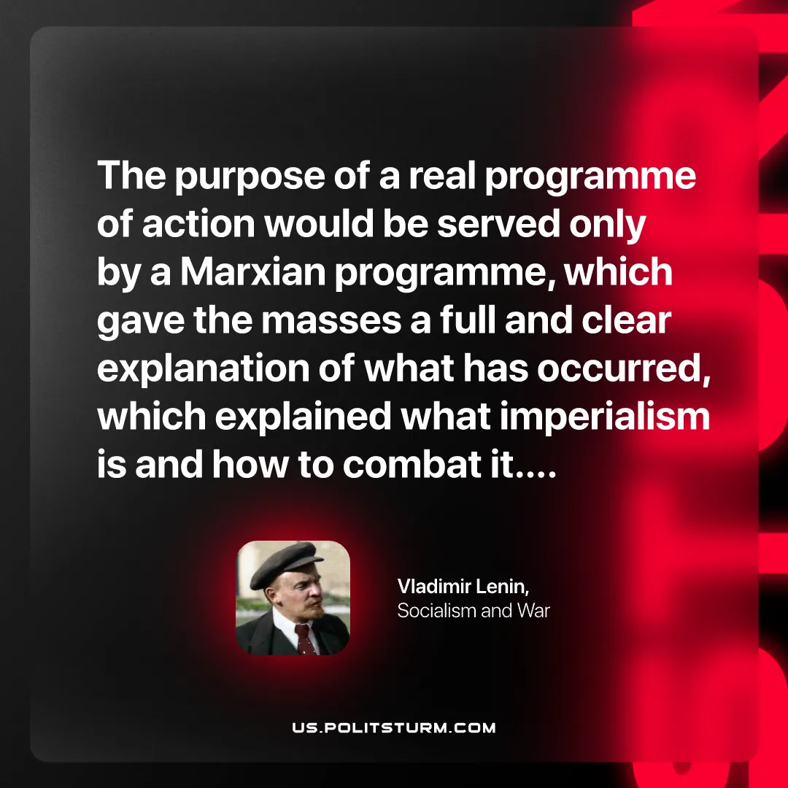

Original article
2025-12-28

“The purpose of a real programme of action would be served only by a Marxian programme, which gave the masses a full and clear explanation of what has occurred, which explained what imperialism is and how to combat it….”Vladimir Lenin, Socialism and War

Original article

