Should Latin American Countries Unite? Criticizing the Bolivarian Revolution
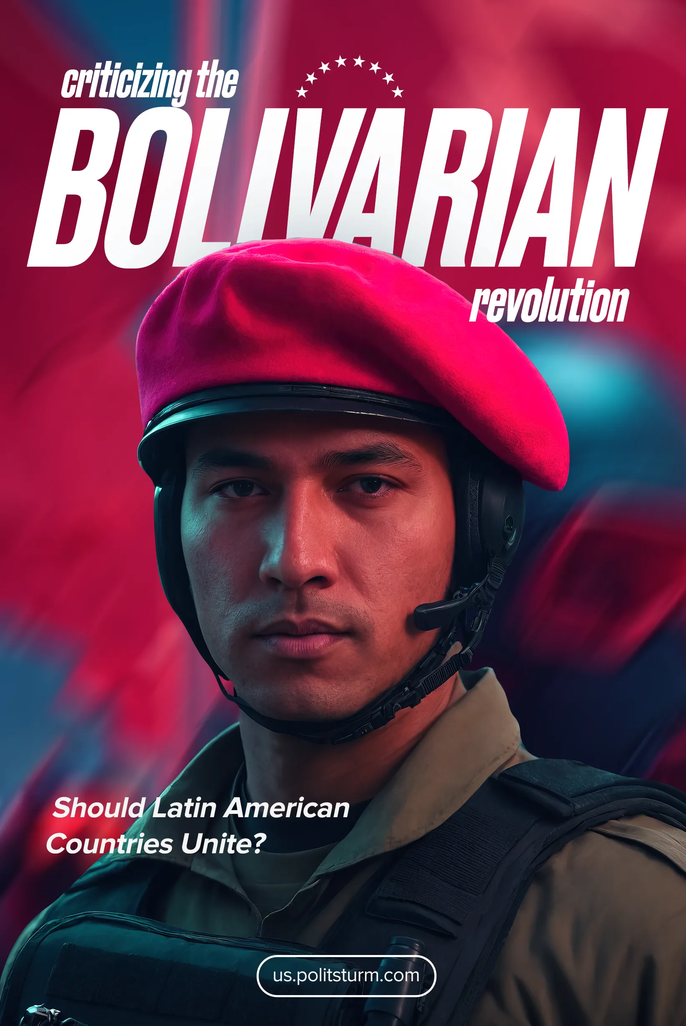

Original article
2024-09-14
26 min read

For several decades now, Latin American integration has been a frequently discussed topic. Several leftist perspectives agree to demand it as one of their main cornerstones, supporting this proposition with different arguments. In most cases, Latin American integration is defined in its "Bolivarian" sense, as a confederation of the peoples that inhabit the American continent and the Caribbean Sea between Mexico and Argentina.
Despite this apparently clear objective, the slogan is articulated ambiguously with socialism, sometimes as a necessary condition before it, sometimes as its natural result. Let us examine some of these perspectives and compare them with other proposals for regional integration in order to determine their class origin.

The Origins of Latin American Integration
The origin of regional integrationist ideas in Latin America is the liberal thought of Francisco de Miranda [1], one of the main leaders of Venezuelan independence and a veteran of the French Revolution and the American Revolutionary War. Before the independence processes, there were some attempts at both separation from the Spanish Empire and local integration.
Within the first type (i.e, separation from the Spanish Empire), we can include the first indigenous rebellions against colonial domination and the consequent restoration of their previous social orders, and on the other hand, also the attempts of some conquerors to establish an absolute personal rule over those colonies.
The second type is referred to as local rather than regional integration, because before the Spanish conquest the largest political entities in terms of their landmass were the Inca and Aztec empires, after which there were some confederations of monarchical communities grouped by language. Due to the limitations of the continent, the lack of domesticable species and geography unsuitable for large transportation infrastructures [2], none of its indigenous societies were able to fully explore it, so it was impossible for them to know the continent and think of it politically.
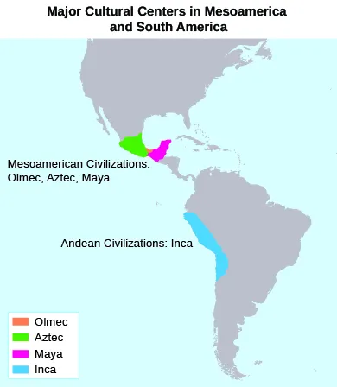
Maximum extensions of the Inca and Aztec Empires and the Maya and Olmec civilizations [3]

Simon Bolivar And His Ideas
Since the first real continental integration, albeit fractured, was carried out by the European colonial powers, the first real revolutionary movements had to respond to the risk of being reconquered by them with regional coordination. Despite this common enemy, the independence processes were not cohesive; they succeeded because at the beginning of the 19th century, thanks to the Bourbon reforms, the immediate interests of most of the classes and social groups in the Latin American colonies coincided, and this led to their convergence around a war of independence. Even Bolivar recognized this:
“More than anyone, I desire to see America fashioned into the greatest nation in the world, greatest not so much by virtue of her area and wealth as by her freedom and glory. Although I seek perfection for the government of my country, I cannot persuade myself that the New World can, at the moment, be organized as a great republic. Since it is impossible, I dare not desire it; yet much less do I desire to have all America a monarchy because this plan is not only impracticable but also impossible. Wrongs now existing could not be righted, and our emancipation would be fruitless. The American states need the care of paternal governments to heal the sores and wounds of despotism and war…
From the foregoing, we can draw these conclusions: The American provinces are fighting for their freedom, and they will ultimately succeed. Some provinces as a matter of course will form federal and some central republics; the larger areas will inevitably establish monarchies, some of which will fare so badly that they will disintegrate in either present or future revolutions. To consolidate a great monarchy will be no easy task, but it will be utterly impossible to consolidate a great republic.
I shall tell you with what we must provide ourselves in order to expel the Spaniards and to found a free government. It is union, obviously; but such union will come about through sensible planning and well-directed actions rather than by divine magic. America stands together because it is abandoned by all other nations. It is isolated in the center of the world. It has no diplomatic relations, nor does it receive any military assistance; instead, America is attacked by Spain, which has more military supplies than any we can possibly acquire through furtive means.”
– Simón Bolívar, Jamaica Letter, 1815 [4].
On the side of the oppressed working classes, the mass of indigenous workers (mainly in mining and agriculture) fought for the abolition of the fundamentally feudal system of the encomienda (where Spanish colonists were entitled to the labor of conquered peoples), while African workers fought for the abolition of slavery.
Other working stratas that were less oppressed, such as the artisans and small farmers, wanted to reduce the taxes and forced monopolies imposed by the Crown, and the merchants wanted to open trade with the rest of the European countries. On the side of the former ruling classes, the landlords fought to deepen their own rule after being freed from the colonial government, while the core of the royalist forces was formed by the crown officials and the rich merchants born in Europe.
This is evidenced by the previous isolation of each of these groups from the other, the frequent indigenous rebellions that were completely independent of the quilombos or palenques (towns founded by refugees from slavery), while the merchants and plantation owners rarely openly opposed the colonial order.
In addition, after many proclamations of independence and even after winning the corresponding wars, these social classes fought civil wars over the organization of the state and national markets, wars between federalists and centralists, and between advocates of free trade and protectionists.
As the fragment of Bolívar quoted above shows, he was initially not very committed to the goal of integrating Latin America into a single state and was very ambiguous about the form it could take. This purpose emerged in the newly independent states of Central and South America, most of them under the rule of military leaders, during the last years of the Spanish presence in that part of the continent [1]. This is not a simple coincidence, as it wasn't the future division of the larger newborn states a few years later.
The military situation, as we have said, favored the integrationist attempts, but the colonial infrastructure was the main obstacle to it and even for the establishment of the states that resulted from the division of the liberated territories. In the colonies, the economy was mainly based on the production of raw materials and basic goods for the metropolis and the purchase of very few processed goods from it, so the transport networks were not suitable for the creation of national markets.
Then, after most of the continent was formally independent, José Martí rescued Bolívar and his regional project as an issue for Cuban independence from Spain at the end of the XIX century. Martí and his thought remained as the basis of the Cuban nationalists who fought for the end of the colonial status of the island, which later became a U.S. colony instead of an independent country.
In the first half of the twentieth century, some Latin American Marxists studied the independence processes in order to understand their class content, to identify the continuity of the class struggles of that period in the new capitalist landscape, and to draw some lessons for the workers' movement in the new reality. Unfortunately, some of them fell uncritically into the chauvinist propaganda of their own states, preferring to feed their founding national myths instead of separating chauvinism from the facts.
“[…] Nations stand up and greet one another. ‘What are we?’ is the mutual question, and little by little they furnish answers. When a problem arises in Cojímar, they do not seek its solution in Danzig. The frockcoat are still French , but thought begins to be American. The youth of America are rolling up their sleeves, digging their hands in the dough, and making it rise with the sweat of their brows. They realize that there is too much imitation, and that creation holds the key to salvation. ‘Create’ is the password of this generation. The wine is made from plantain, but even if it turns sour, it is our own wine! That a country's form of government must be in keeping with its natural elements is a foregone conclusion. […]
[…] The self-evidence facts of the problem should not be obscured, because the problem can be resolved, for peace of centuries to come, by appropriate study, and by tacit and immediate union in the continental spirit. With a single voice the hymn is already being sung; the present generation is carrying industrious America along the road enriched by their sublime fathers; from Rio Grande to the strains of Magellan, the Great Semi, astride its condor, spread the seed of the new America over the romantic nations of the continent and the sorrowful islands of the sea!”
– José Martí, Our America, 1891 [5].
In Colombia, the initiator of the Bolivarian trend in Marxism was Gilberto Vieira. He wrote an article in 1942 criticizing the article that Marx wrote about Bolivar for the New American Encyclopedia in 1858. In his article, Vieira overemphasizes Simón Bolívar's participation in the expulsion of the Spanish from their colonies in northern South America as his "glorious ascent".
He initially tries to ignore his class origin (one of the largest plantation owners in Venezuela) as an influential factor in Bolívar's revolutionary years, but later recognizes it as a determinant factor in his government of Greater Colombia (a single state that united the territories of present-day Colombia, Venezuela, Ecuador, Panama, and parts of Peru, Brazil, and Bolivia), considered as a second stage of decadence [6].
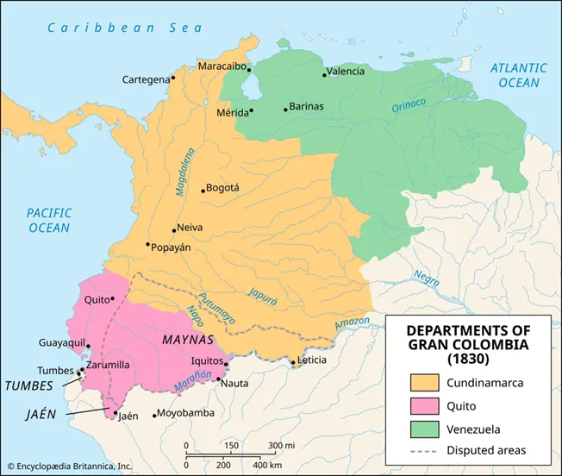
Map of the Greater Colombia in 1830 [7].
For Vieira, Bolívar was a brilliant military leader who sacrificed his personal wealth for independence, but who wasn't able to govern the territories because he "only saw the superficial phenomena" of the colonial situation. Then, after failing to build a prosperous nation of Greater Colombia, his frustration made him a victim of his own figure and the influence of his class [6].
We shouldn't forget that the class character is not a voluntary trait of a person or a group, and it is not abandoned by sacrificing the immediate interest for an idealistic goal, but it is the whole social context of persons and groups (based on their way of living and their property relations) that mostly determines their way of acting and thinking.
Bolívar didn't have a clear economic project apart from the colonial system he benefited from, and he didn't have a defined political project for Greater Colombia, so he first tried to establish a republic, and after that failed, he relied on ruling in the same way that his family managed their cacao plantations.
Apart from that, the article defends some revisionist ideas, including one of their slogans: "[t]hose who consider themselves Marx's disciples always bear in mind the master's warning that their system is not a dogma but a guide to action" [6]. Of course, any scientific theory is a "guide to action" rather than a "dogma," but that doesn't mean that any part of it can be refuted without evidence or ignored at the will of the people who try to apply it.
The second revisionist idea in the article is that the leaders of the pre-capitalist revolutionary movements could only come from the privileged classes because of the ignorance of the poorer ones. With this, Viera tries to deny the possibility of other leaderships in these processes and returns to an obsolete view of history as a product of heroes by overemphasizing the role of an individual leader over the rebellious masses.
The medieval peasants were not able to lead the abolition of feudalism because their immediate interests were not qualitatively opposed to the basis of feudalism, which was only the case with the merchants and the workshop owners. In the same way, today's industrial workers live day by day in large-scale cooperative and coordinated production, which materially refutes any pretended justification of competition and personal profit as the main force of progress, as it was in the first decades of industry.
The last revisionist idea of this text is the equivalence he made between the anti-colonial struggle of the beginning of the XIX century and the modern anti-imperialist struggle in a worldwide expanded capitalism. He affirmed in the article that Bolívar's struggle for national liberation still had to be completed since complete national independence had not been achieved at that time.
The last part is just another classic trick of the reformists, putting intermediate stages before socialism, which is effectively abandoned when a country is completely incorporated into the world market and carries out its production through industrial machinery.
In other words, pointing to some "peculiarity" or "semi-feudal" feature of the national economy in order to propose another bourgeois-democratic revolution when the basis of the economy is capitalist is exactly what the Mensheviks did in 1917: subordinating the class interests of the workers to a section of the bourgeoisie. The first part is a gross transplantation of the forms of two fundamentally different processes that will naturally end up repeating the mistakes of the first, such as waiting for a multi-class alliance before engaging in anti-imperialist political struggle, or thinking that our countries are tied to a single metropolis instead of a system that articulates local and world economic relations of dependence in different degrees.

The Cuban Revolution, Guevarism And Its Influence On Latin American Integration
With the Cuban Revolution of 1959, Bolivarian ideas, seen through the works of Martí and mixed with the Third Worldism of the era, gained popularity among leftist movements in Latin America. This led to a wave of adventurist eclecticism in the continent, a wave that grouped many forms of nationalism, indigenism, Trotskyism, and other trends, but the most representative among them was Guevarism [8].
Guevara himself thought about Latin American integration in terms very similar to those of the leaders of the independence processes. He considered the common colonial past and its vestiges in the Latin American economy, such as local inequalities within countries and the persistence of large-scale agricultural production, as the main basis for regional integration. Above this, Guevara placed the region's Hispanic heritage as a cohesive factor for integration, as part of a larger process of coordination among former colonial nations [9].
We can conclude that Guevara, like other theoreticians of Latin Americanism, had a Third Worldist view of imperialism that placed national oppression above class oppression and regional specificity as the justification for his regionalism. Moreover, one of the main features of his thought is his belief in consciousness as a means of overcoming material limitations, which is reflected in this issue in the form of an insufficient analysis of the necessary conditions for the creation of nations.
Guevarism not only led to an era of adventurist guerrillas who isolated themselves and the most active revolutionary youth from the working masses but were eventually defeated by militarist reactionary governments. This political tendency was adopted by several revisionist and non-Marxist movements and acted to some extent as a cohesive factor among them, although this cohesion was partial and there were often violent conflicts within the movements influenced by it.
An example of this and its unpleasant consequences is the creation of the Montoneros in Argentina, an urban guerrilla founded under the heterogeneous convergence and mixture of left-wing Peronism, liberation theology and Guevarism [8]. The Montoneros were massacred by both state forces and the Peronist right and became the main justification for the era of state terror in Argentina between the third government of Perón and the military dictatorship that ended in 1983.
Another integrationist trend is indigenism, which cannot be completely separated from the others because of the eclecticism of these movements. The indigenism we refer to comes from the writings of José Carlos Mariátegui, who argued for the existence of an Inca communism, which was simply a product of his confusion (with a dose of racism) between communitarian work and land management under the Inca Empire and communism as the classless industrial society we want to build [10].
It's obvious that communitarian forms of production have existed in almost every class society without making it communist, from the common lands of the gens in ancient Rome to contemporary cooperatives. This doesn't mean in any way that we should necessarily antagonize these forms of production, they could be supported and expanded as a basis for the integration of small-scale production into socialism, but they cannot replace the complete socialization of large-scale production, and they are not by themselves a form of socialism.
Despite his accurate characterization of the independence processes (given the limited information available at the time), Mariátegui declared that Latin American countries didn't have a bourgeoisie, since the elites who integrated these countries into global capitalism were the feudalistic landowners installed by the colonizers who later rebelled against the metropolis.
The landscape of Peru that he describes shows the ongoing industrialization of its former colonial extractive economy and its full integration into world and regional market systems, the Peruvian economy was already capitalist in content, although it retained some feudalistic forms.
Mariátegui's characterization of the Peruvian economy as semi-feudal was a common trait of contemporary revisionist leaders, who overemphasized this already dissolving backwardness as a peculiarity that made it necessary to complete the bourgeois-democratic revolution before beginning the struggle for socialism.
He cited the English colonization of North America as an example of the progressive implementation of a capitalist society, despite its more aggressive extermination of the indigenous population. Even more damaging was his mistaken view of the Inca Empire, which led several movements to advocate a return to that already obsolete society, some to the point of deliberately imitating fascism, like the Ethnocacerists in Peru (they named their movement after a leader of the anti-Chilean resistance) [11].
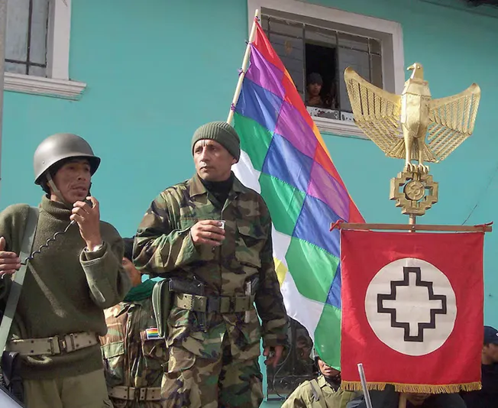
Antauro Humala (center) in an Ethnocacerist meeting after leading a military takeover of a police headquarters [12].

Venezuelan Chavism And Contemporary Integration Initiatives In Latin America
Today, the main representative of integrationist ideas in this part of the continent is Chavismo and its local reformist allies. We have already analyzed the nature of Chavismo, its origins and its necessary results, so we will limit ourselves here to a brief analysis of its integrationist attempts.
Since the decade of the 1980s, several initiatives for a common market were created in the Latin American region, but it was not until the 1990s that liberal free trade initiatives blossomed. In parallel with the pan-American NAFTA (North American Free Trade Agreement) proposed by George Bush in 1990, several South American countries signed a treaty in 1991 to create a South American Common Market (Mercosur).
In addition, this decade saw the signing of several two-state free trade agreements throughout the region. This plethora of agreements was based mainly on the reduction of tariffs and sometimes the relaxation of border controls through pacts that avoided the creation of a supranational entity.
As a result of Mercosur, Latin American countries formed a regional trade bloc and gained bargaining power in relation to the United States, which preferred to negotiate with individual countries or sub-blocs [13]. Not to mention the OAS (Organization of American States), which served primarily as a political tool for the U.S. to sanction and exclude those countries that tried to escape its influence.
Apparently opposed to this liberal integration, the Venezuelan government of Chávez created three entities to constitute a "real integration" of Latin America: the ALBA-TCP (Bolivarian Alternative for the Peoples of Our America - Peoples' Trade Agreement in 2004), UNASUR (a treaty for the union of South American countries in 2008), and CELAC (Community of Latin American and Caribbean States in 2001). These initiatives were widely supported by the reformist governments of the region in their early years [14].
The Chavista integration initiatives did not differ substantially from the previous liberal agreements; their main difference was in rhetoric. Instead of referring to multinationals as such, they used the term "greater-national companies," which aimed to "break the logic of capital accumulation" through "fair trade" and consensual decisions in the framework of solidarity and goodwill. In this rhetoric, the "greater-national companies" serve the larger purpose of "consolidating the sovereignty of our peoples and building the road to socialism.
The inspiration for this rhetoric came from the utopian socialism and mutualism of the 19th century, which proposed the "social economy" as a way to overcome capitalism. The rhetorical cloak of these initiatives was, of course, the social liberalism of Simón Rodríguez, Bolívar's teacher, and an eclectic glorification of several of the subcontinent's rebel heroes.
The historical figures not associated with Bolívar were merely named, rather than explained in their historical contexts, regardless of their positions among themselves or toward the independence movements, more like a shopping list than anything else. A poorly understood anti-imperialism was another element of the integrationist proposal, it was just the usual Third Worldist identification of the US-Europe bloc with the whole imperialist system and a complete negligence towards further analysis of the economic and historical process of imperialism [14].
It's only a natural consequence that this "integration" would lose its initial support as the reformist wave in the region weakened. The deliberately ambiguous and poorly defined documents of these entities made it clear that any positive outcome of them could only be the result of chance. In 2021, the group of reformist leaders that remained in government signed the Puebla Group Manifesto, which blamed U.S. political interference for the effective dissolution of regional integration and denounced "hybrid warfare" and lawfare processes as the means of that interference [14]. As a result of its eclecticism, Latin American social democracy has been completely incapable of self-criticism and of making a minimal objective diagnosis of the reasons for its failure; of course, US interference exists, but it cannot be the only cause for the failure of reformist projects.
Lenin already warned us of such situations, which are hardly new in the politics of the capitalist world:
“On the other hand, the socialists of the oppressed nations must, in particular, defend and implement the full and unconditional unity, including organisational unity, of the workers of the oppressed nation and those of the oppressor nation. Without this it is impossible to defend the independent policy of the proletariat and their class solidarity with the proletariat of other countries in face of all manner of intrigues, treachery and trickery on the part of the bourgeoisie. The bourgeoisie of the oppressed nations persistently utilise the slogans of national liberation to deceive the workers; in their internal policy they use these slogans for reactionary agreements with the bourgeoisie of the dominant nation (for example, the Poles in Austria and Russia who come to terms with reactionaries for the oppression of the Jews and Ukrainians); in their foreign policy they strive to come to terms with one of the rival imperialist powers for the sake of implementing their predatory plans (the policy of the small Balkan states, etc.).”
V.I. Lenin, Socialist Revolution and Self-Determination, 1916.

Conclusion
Given Venezuela's increasing dependence on foreign capital from China and other "alternative imperialisms," along with companies like Chevron, from traditional U.S. imperialism, which we have previously written about, this quote from Lenin expresses very well the nature of the integration proposed by Chavismo. Moreover, as we have already shown with the regional free trade agreements of the 1990s, the slogan of integration by itself has no revolutionary or anti-capitalist content. Even today, such imperialist institutions as the World Bank continue to defend it [15] and changing the wording of the proposal with left-wing appealing references would bring about insignificant changes.
As for the other integrationist perspectives discussed here, it's obvious that they fail to analyze the development of capitalism in dependent countries. In every natural or social phenomenon there are laws that govern its internal development and its interaction with the environment, some of these laws are more determinant than others. Moreover, the peculiarities of a particular instance of a phenomenon don't deny its fundamental conformation and, consequently, the validity of the same laws that govern other instances.
In the specific case of the struggle for socialism in various countries, including the dependent ones, Stalin revealed its basis:
“You speak of Sinified socialism. There is nothing of the sort in nature. There is no Russian, English, French, German, Italian socialism, as much as there is no Chinese socialism. There is only one Marxist-Leninist socialism. It is another thing, that in the building of socialism it is necessary to take into consideration the specific features of a particular country. Socialism is a science, necessarily having, like all science, certain general laws, and one just needs to ignore them and the building of socialism is destined to failure.”
I.V. Stalin, From the Conversation with the Delegation of the CC CP of China in Moscow, 1949 [16].
In the general sense of the problem, we can conclude that regional integration in any country only means a bourgeois or petty-bourgeois slogan that discards genuine proletarian internationalism and replaces it with chauvinism.
Under capitalism, successful experiences of regional integration are the result of the emergence of local imperialist powers, most of the time acting as intermediaries with the world imperialist centers. Of course, as communists, we should study the history of the workers of our own country in order to draw lessons that could help us in our current activity, but we must not fall into the mistake of repeating them and expecting that they will develop in this modern stage of capitalism as they did in their respective historical contexts.
If you want to help build a worldwide communist movement that correctly studies and addresses the contemporary problems of capitalism and avoids falling into clichés, please join us.
Sources:
[1] Monta, J. "El concepto de la independencia en América Latina". URL: https://biblioteca.clacso.edu.ar/clacso/formacion-virtual/20160316032539/07monta.pdf — (March 16, 2016).
[2] Diamond, J. Guns, Germs, and Steel: The Fates of Human Societies. W.W. Norton & Company: 1997.
[3] OpenEd CUNY. "The Atlantic Slave Trade". URL: https://opened.cuny.edu/courseware/lesson/310/overview — (June 2023).
[4] Bolívar, S. "Jamaica Letter". URL: https://www.hursthistory.org/uploads/1/0/7/0/107013873/jamaica_letter.pdf — (May 25, 1815).
[5] Martí, J. "Our America". URL: https://writing.upenn.edu/library/Marti_Jose_Our-America.html — (January 1891).
[6] Vieira, G. Sobre la estela del Libertador: El criterio marxista acera de Bolívar. Editorial Marxista: 1942.
[7] Britannica. "Gran Colombia". URL: https://www.britannica.com/place/Gran-Colombia — (March 5, 2023).
[8] Martínez, L. "Bolívar y el Panamericanismo". URL: https://doi.org/10.24215/16696581e003 — (January 15, 2018).
[9] Fernández, R. "La influencia de Bolívar en América Latina". URL: https://dialnet.unirioja.es/descarga/articulo/6531576.pdf — (June 10, 2018).
[10] Mariátegui, J.C. "Seven Interpretive Essays on Peruvian Reality". URL: https://www.marxists.org/archive/mariateg/works/7-interpretive-essays/essay03.htm — (July 2023).
[11] Góñaz, W.Z. "El pensamiento de Simón Bolívar". URL: https://red.pucp.edu.pe/ridei/files/2011/08/1002.pdf — (August 2011).
[12] La Tercera. "La ideología antichilena de Antauro Humala: El etnocacerista que quedó libre en Perú". URL: https://www.latercera.com/mundo/noticia/la-ideologia-antichilena-de-antauro-humala-el-etnocacerista-que-quedo-libre-en-peru/5MO5BXFN4FG5XB35U6YC5BGU6Y/ — (February 2023).
[13] European Institute of Public Administration. "The Scope of Regional Integration". URL: https://www.eipa.eu/wp-content/uploads/2017/11/Scop93_2_1.pdf — (November 2017).
[14] López, A. "Integración en América Latina". URL: https://doi.org/10.24215/24689912e037 — (December 2020).
[15] World Bank. "Deeper Integration Vital for Growth in Latin America and the Caribbean". URL: https://www.worldbank.org/en/news/press-release/2017/03/14/deeper-integration-vital-for-growth-in-latin-america-and-the-caribbean — (March 14, 2017).
[16] Revolutionary Democracy. "China and Latin America". URL: https://www.revolutionarydemocracy.org/rdv16n1/china.htm — (2017).

Original article

