Larry Summers on the Need for More Billionaires
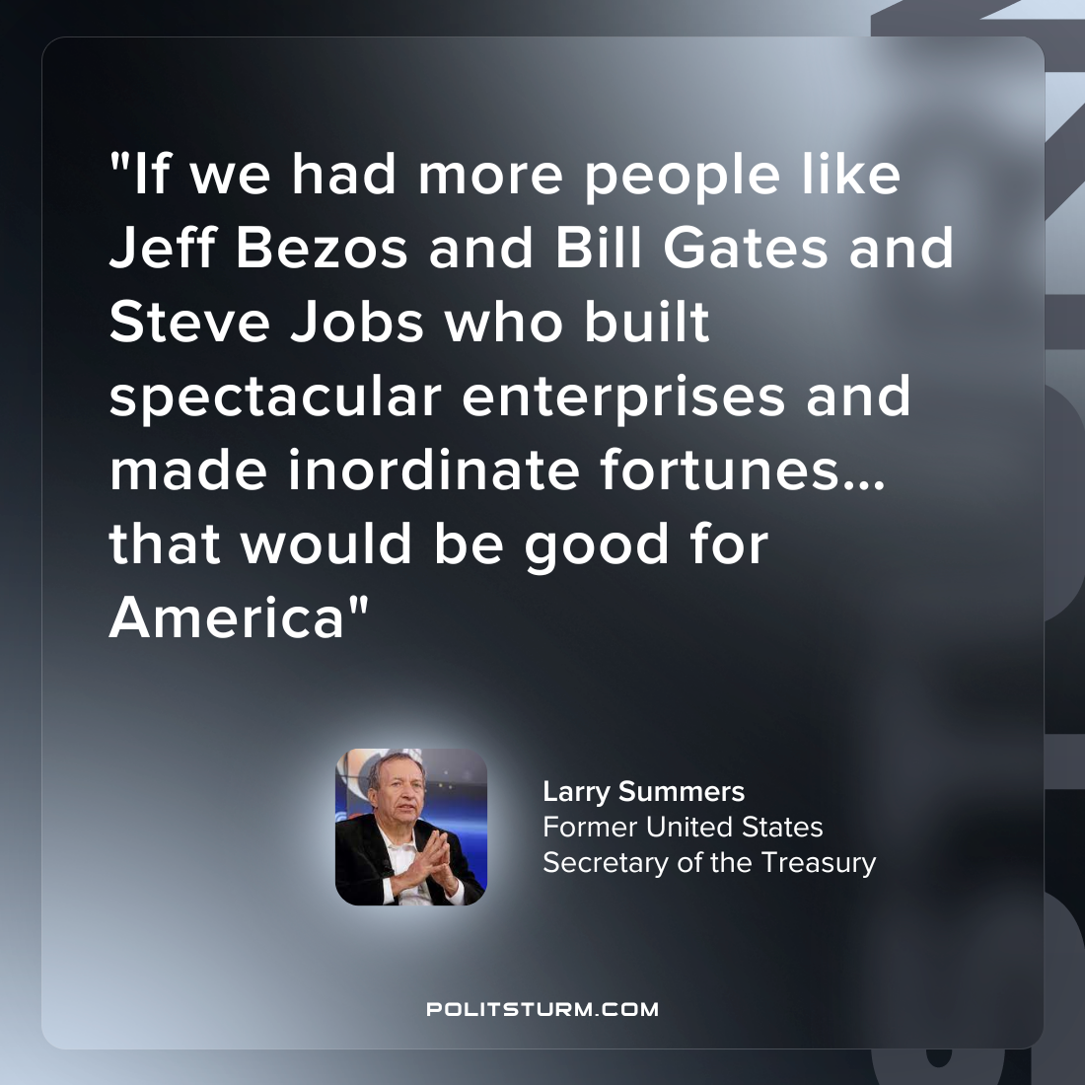

Original article
2022-09-22

“If we had more people like Jeff Bezos and Bill Gates and Steve Jobs who built spectacular enterprises and made inordinate fortunes…that would be good for America”
Larry Summers
Former United States Secretary of the Treasury

Original article

