Large American Investments In Russian Economy
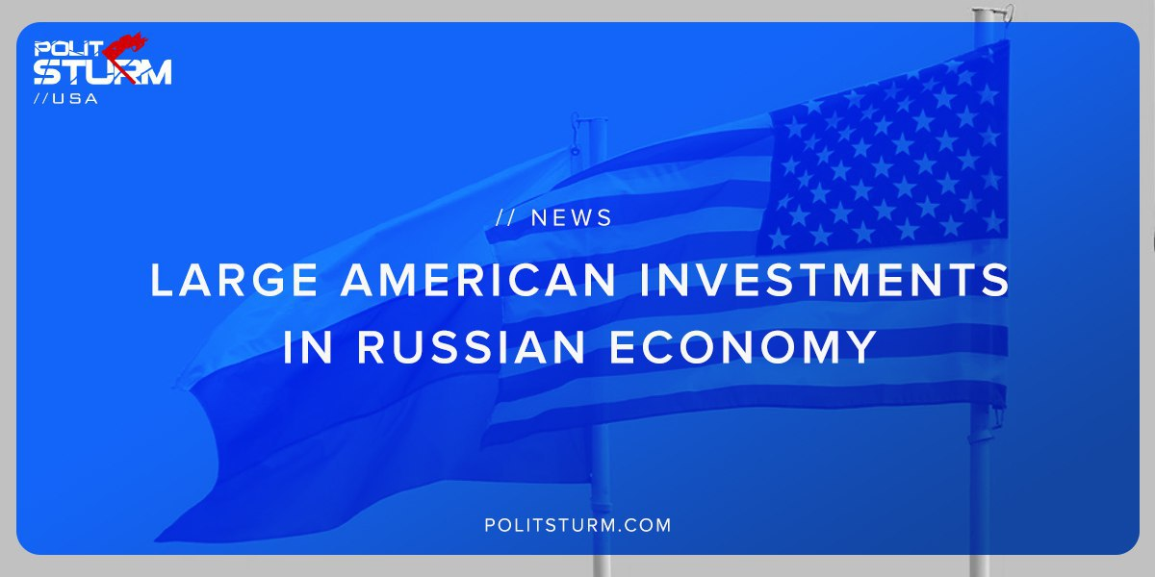

Original article
2019-06-30
1 min read

According to a recent study by the United Nations Conference On Trade and Development (UNCTAD) the United States was the largest investor in the Russian economy as of the end of 2017.
American investments were $39.1 billion, which amounts to 8.9% of total foreign direct investments into Russia. The official estimate provided by the Office of the United States Trade Representative was dramatically lower at $13.9 billion for the same time period. Likewise, the Central Bank of Russia underestimated the figure at a mere $3.05 billion, 13 times lower than the United Nations estimate.
While both countries underestimate the value of capital exports from the United States into Russia, the underlying logic of such a situation is obvious. Investors are able to funnel capital, either directly or through subsidiaries, into the Russian economy to extract profit.
While the capitalists of both countries benefit from such an arrangement, it is important for both countries to promote antagonistic, nationalist propaganda in order to protect the oligarchs of both countries. It is necessary to expose the symbiotic relationship of the national bourgeoisie of various countries and not fall victim to the promotion of nationalist rhetoric which merely serves the interests of the capitalist class.
Sources: 1, 2, 3

Original article

